Assignment 1 Data Visualisation

Ryan Wood

Data Analyst Bootcamp

23/08/24

Table of Contents

Introduction 2

Scenario 2

Policies and Procedures 2

Excel 3

GDP Tasks 3

Set a password to protect the workbook. 3

Change the data to display in British Pound symbol. 5

Turning the GDP Sheet into a table 6

Using my Creative Skills to edit the chart 10

Move the chart to a new sheet tab and label with a suitable name. 16

Create a sort for the top 20 highest ranking countries. 17

Creating bar chart to to display the highest ranking 20 countries from my sort and placing it under the table. 19

Colouring the background and Highlighting the area beneath the table. 22

Creating Macros and Macro Buttons 24

Copy The Worksheet Using The Macro. 29

Adding Headers and Footers. 30

Save Excel Document as ‘Excel Gross domestic product report 1’ 30

Tableau 31

Import Data 31

Set Relationships 31

Check Data Types 33

Build Charts 34

First Chart – Bar Chart 35

Second Chart – Tree Map 38

Third Chart – Box And Whisker Plot 40

Fourth Chart – Filled Map 44

Build A Dashboard 50

Reflection 53

## Introduction

# Scenario

In order for a client to better understand and gain improved insights into their business model and in turn be empowered to take decisions which improve business outcomes and lead to better experiences I have been tasked with creating a visual report using the provided “Wealth Of Nations” data set to help inform the client, the report will combine charts and maps within tableau and will be considerate and compliant to the policies surrounding Data protection and computer misuse.

## Policies and Procedures

*Imperva.com* describes three key strategies regarding successful data protection as:

* **Data Security** - Protecting data from accidental or malicious damage
* **Data Availability** – Quickly restoring data in the event of damage or loss
* **Access Control –** Ensuring data is accessible to those that actually need it and not anyone else.

My takeaway from these points, from the perspective of a data analyst is that the protection of the subject of the data and the integrity of the company must be at the forefront of any actions taken by a data handler. Therefore, a safeguard and an acknowledged set of agreed behaviours must be in place, to help regulate what can and cannot be done within varying roles across data professions, these are the policies and procedures.

Before working with the “Wealth of Nations” data set it is essential that I adhere to the correct policies and procedures set out by my client’s business. These policies and procedures importantly serve to provide an understanding to myself of how to remain lawful within my use of company data.

A *Google AI overview* of a **Data Protection Policy** determines that it contains details of how a company will carry out their use of data lawfully, this includes the methods of how they interact with data, how they apply data minimalization (the commitment of only gathering and harnessing relevant data for a specific use) as well as the means taken to protect the rights of the data subjects. The policy should also detail the system security measures in place as well as the company’s policy and tools to ensure the continuous training of staff in relation to data security and proper handling. It is important as a data analyst that I do not breach the terms and conditions of the policy by leaving the data at risk of falling into the wrong hands or interact with the data unethically.

A **Data Governance Policy** lends itself to the business as an explanation of the rules for the employees and data handlers in the business itself. This policy is aligned most fundamentally to the pillar of Data Management, the responsibilities of which include appropriate and lawful: **collection**, **processing**, **analysis,** **storage** and **protection** of data. *Atlan.com* describes additional principles of a comprehensive data governance policy including: **data quality**, **privacy**, **security**, **lifecycle**, **ethics**, **definitions** and **models**.

As a data analyst I must fully understand the impact of my use of data across the entire data lifecycle, ensuring that the data I receive is relevant to my pre thought out purpose only, and once the appropriate analysis is carried out, and my use of the data is complete I should protect the data set compliantly and safely so that the next potential user of the data has been given the proper permissions to access it and to prevent risk of avoidable errors being made or even deletion of valuable and sensitive data.

Data producers such as data analysts also play a part in the maintenance and development of data governance policies, their experience and requirements of access to data during its processing, cleaning and transforming period is of key importance when the framework of a governance policy is being constructed or built on.

Importantly these policies are acknowledged by the parties involved within the business by signature, to cement a lawful agreement that the content of the policies has been understood and that a commitment has been made by the individuals in the organisation to use data within the lawful perimeters set out in the framework of the policies.

## Excel

# GDP Tasks

### Set a password to protect the workbook.

1. Select “Review” from ribbon.

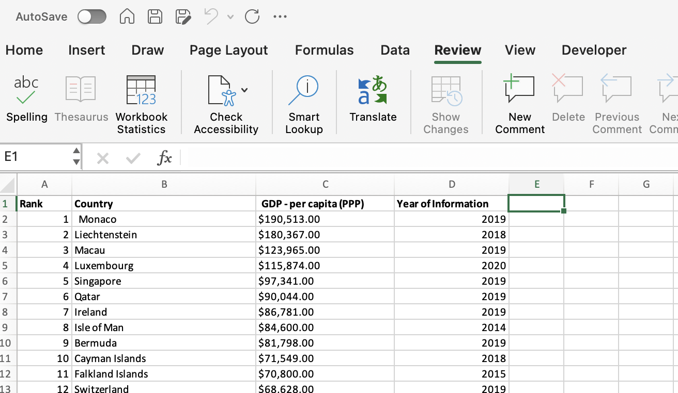

1. Select “Protect Workbook”

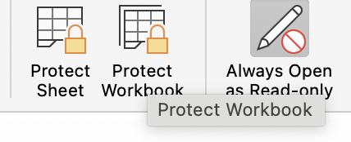

1. Enter Password and Verify it, tick or untick “Protect Structure” to disable or enable modifications to the workbook (e.g creating or deleting new or existing worksheets) Click Ok.

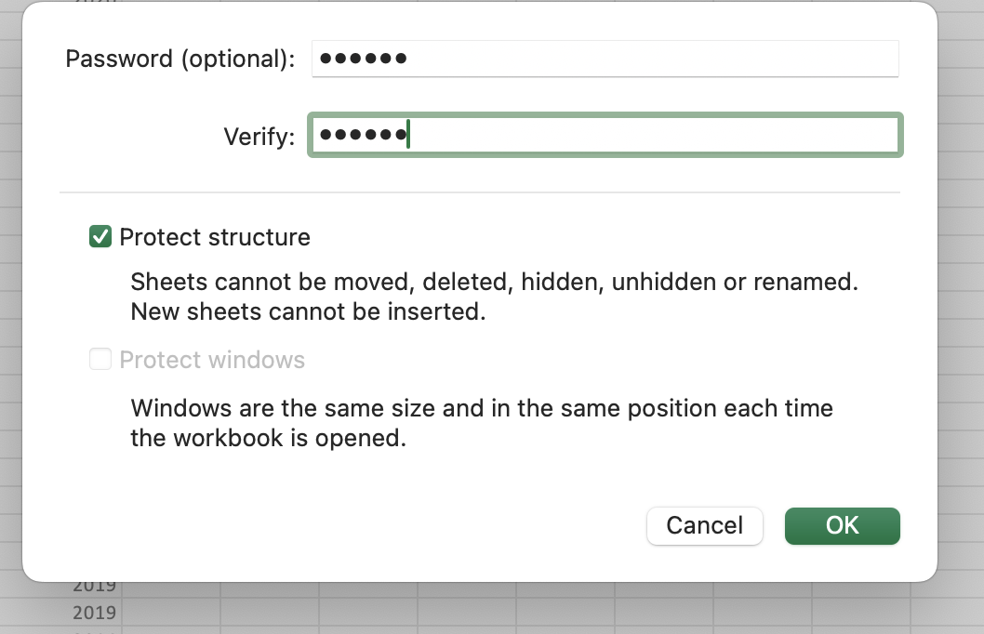

1. The Password is now required to access the workbook.

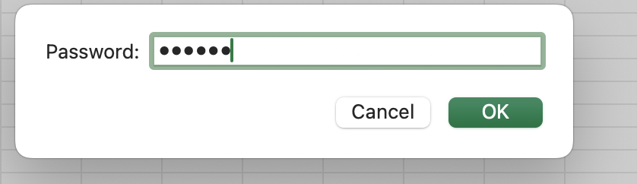

### Change the data to display in British Pound symbol.

a) Highlight Column C as this is the current currency data displayed in Dollar format.

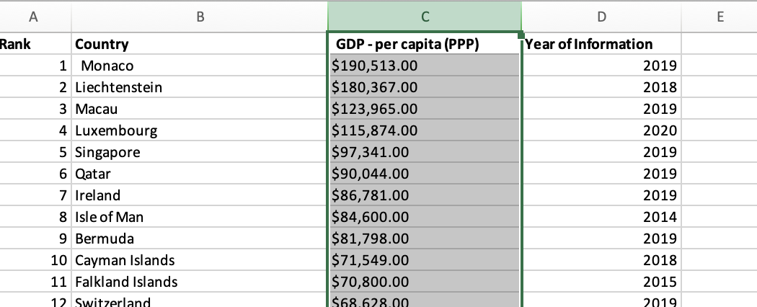

b) Right click highlighted column, and select format cells.

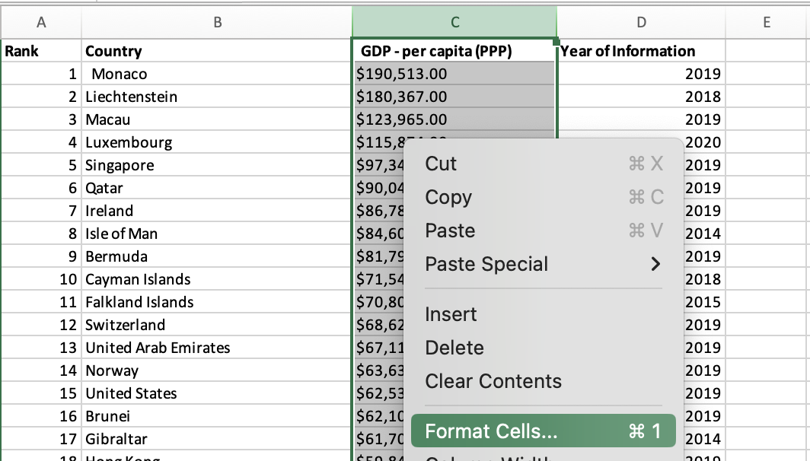

c) Under “Number” tab, Select “Currency” and select the Symbol dropdown box.

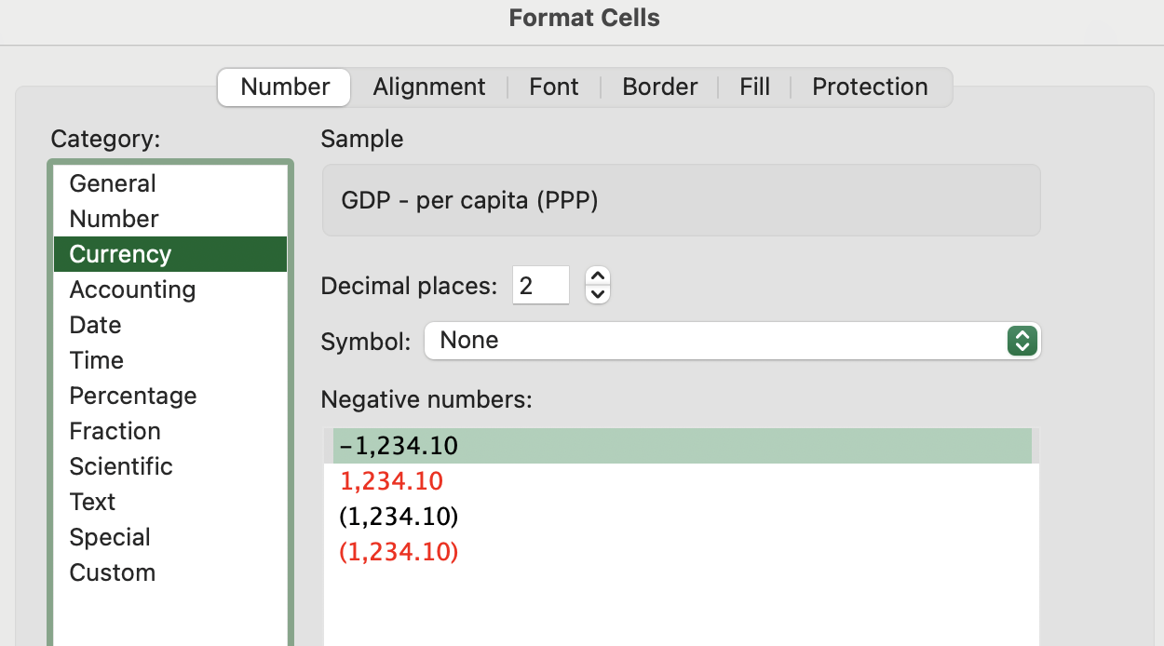

1. Select British Pound Symbol and click Ok.

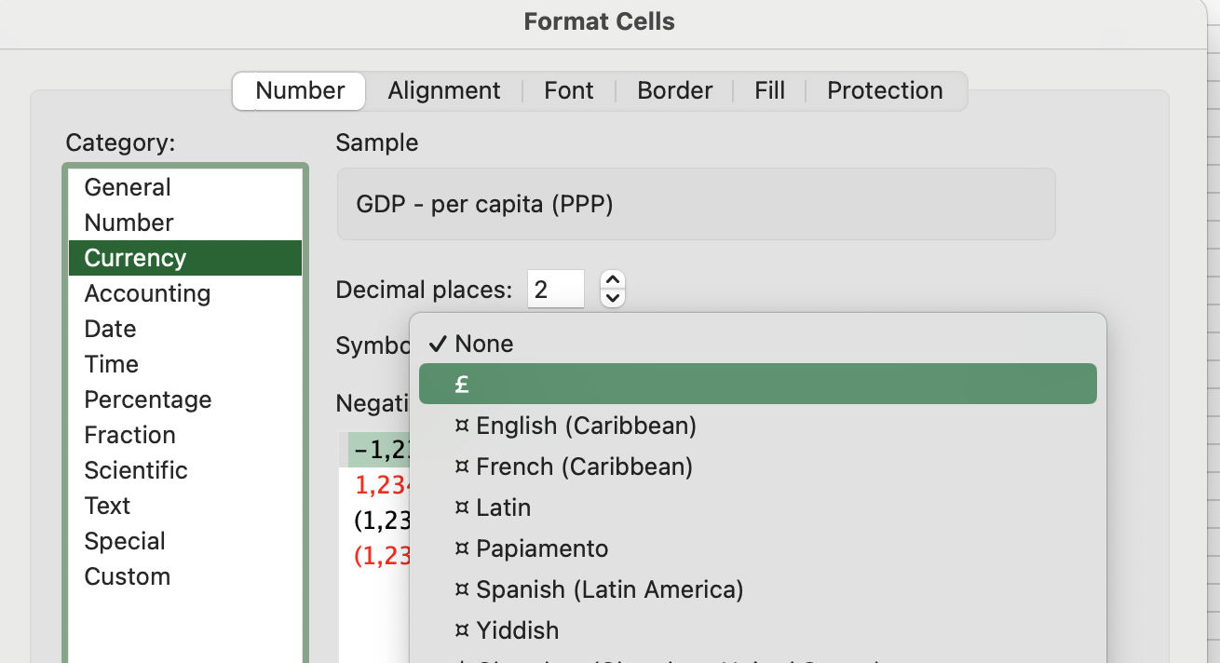

1. Currency for column C has now been amended to British Pound Symbol.

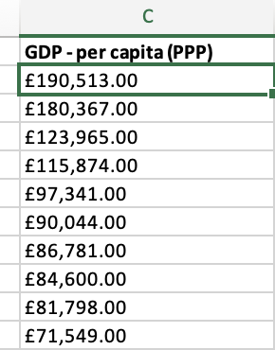

### Turning the GDP Sheet into a table

a) select cell A1.

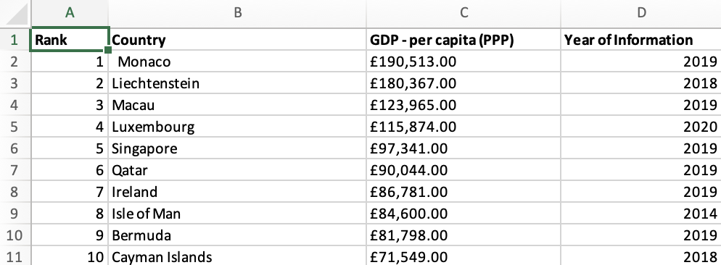

b) Select “Insert” ribbon and Table option.

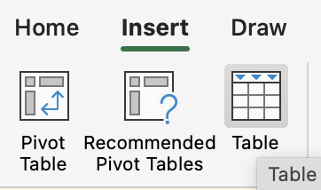

c) Check create table menu has full range of data selected and “My Table has headers” has been ticked and click Ok.

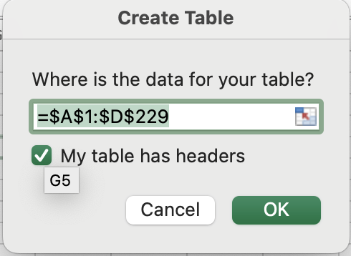

d) Data has now been converted into a table.

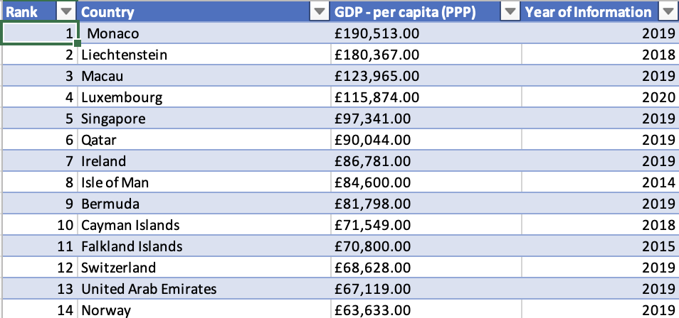

#### Filter the Table to only display information for 2019.

a) Select drop down arrow for “Year of information” column.

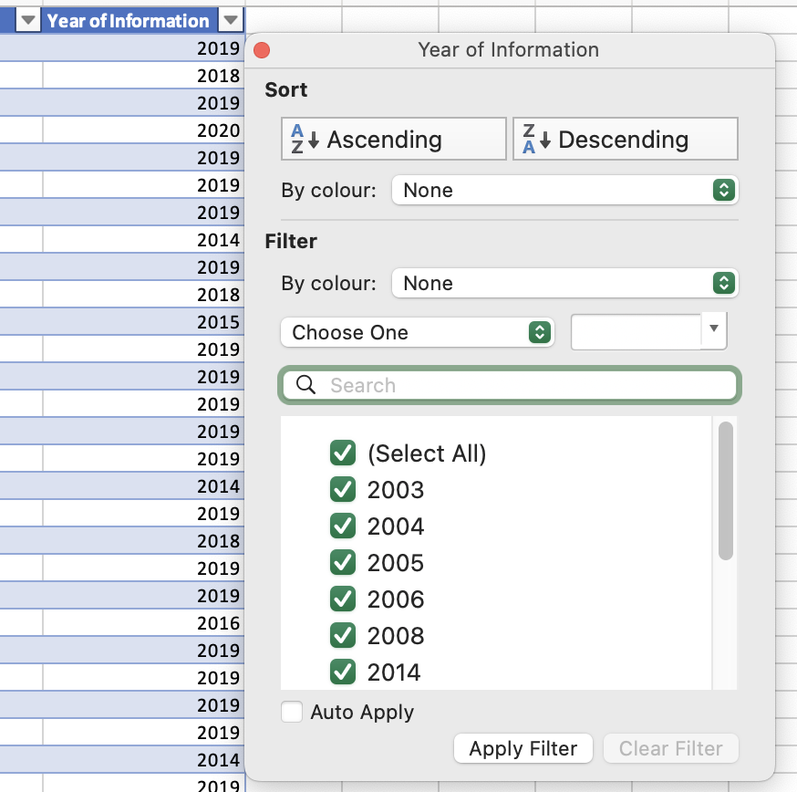

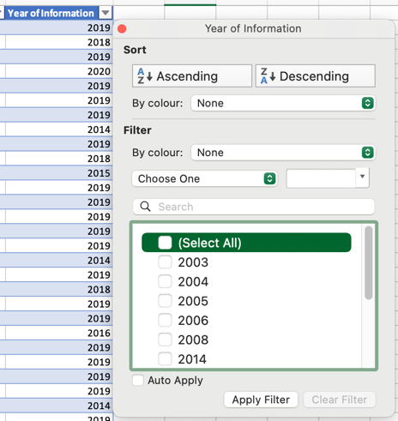b) Deselect “select all”.

c) Scroll down and select “2019” and apply filter.

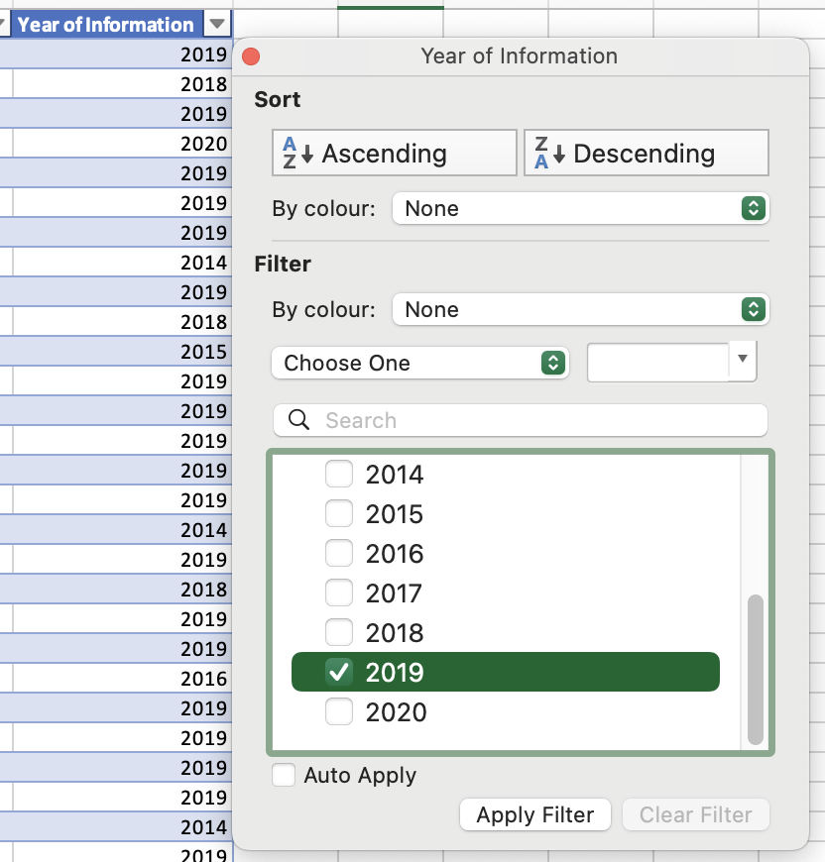

d) Table has now been filtered to show only results from the year 2019.

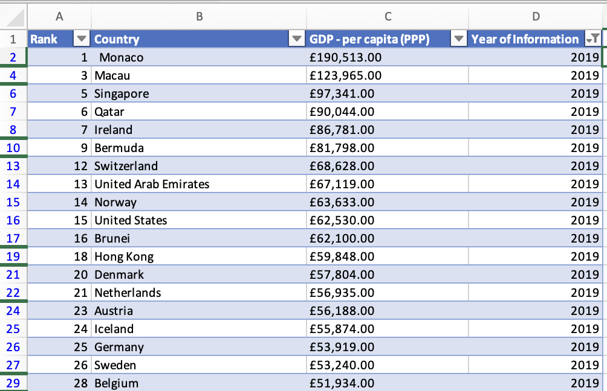

#### Create a chart to display Rank, Country and GDP - per capita (PPP)

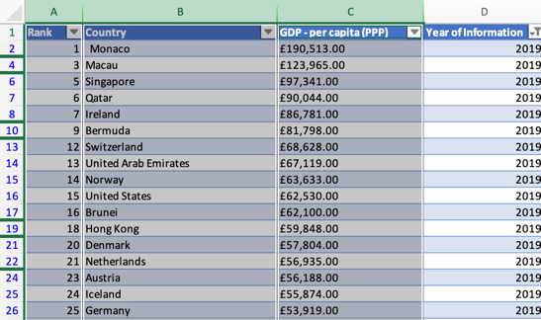a) Select columns for Rank, Country and GDP.

b) Select Insert ribbon, and your choice of chart for data from the drop down tab.

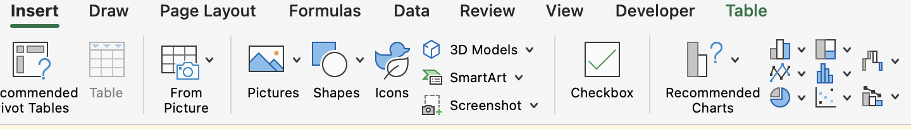

c) I select a 2D column chart as this is an efficient chart for displaying multiple categories along an X axis and numerical values vertically along the Y axis.

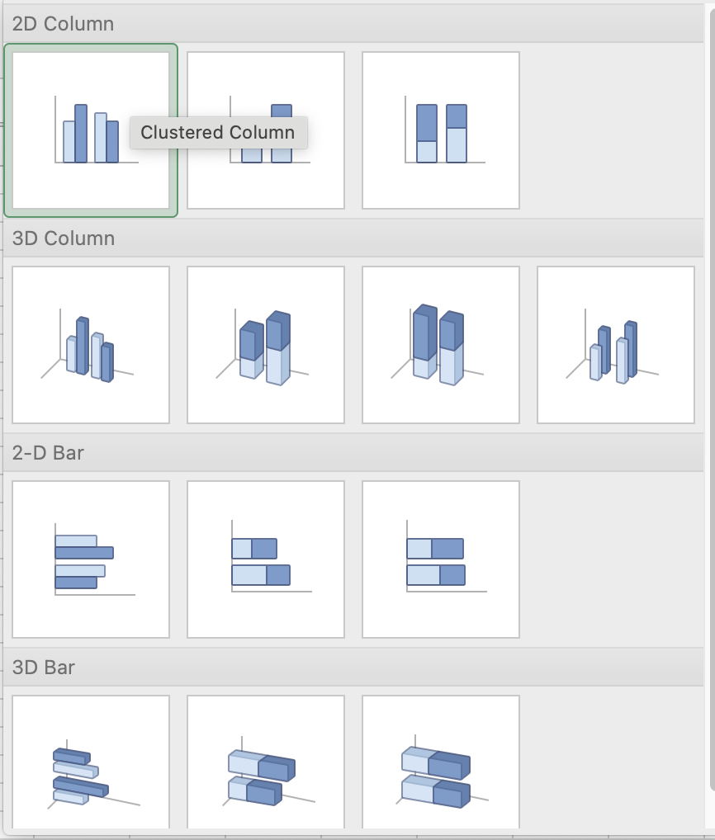

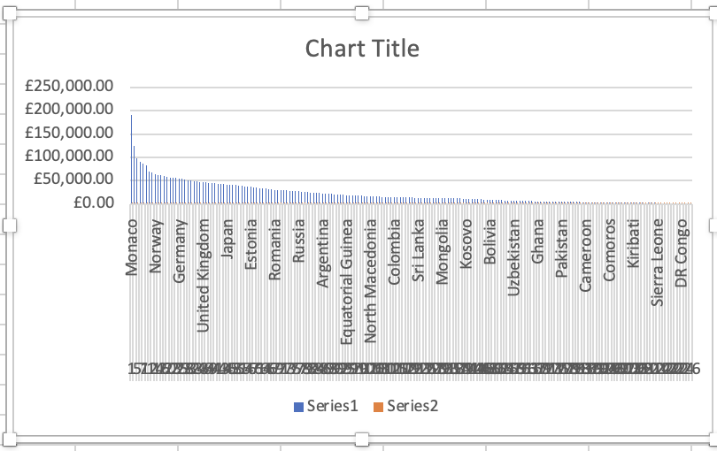

Y axis for numerical values (E.G GDP)

X axis for categories (E.G Countries)

### Using my Creative Skills to edit the chart

a) I am now going to give the chart a new title. I click on the “Chart Title” and enter “Rank of Countries by GDP Per Capita in 2019”

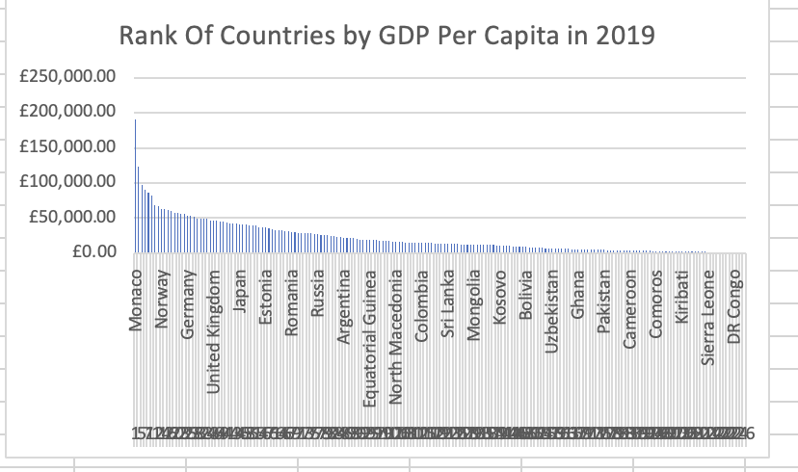

b) Next under “Chart Design” ribbon I will select “Add Chart Element” from the top right of the screen.

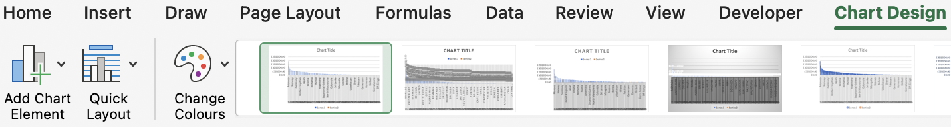

c) From the drop down menu I will hover the cursor over “Axis Titles” and select from “Primary Horizontal” (X Axis) and “Primary Vertical” (Y Axis) we will be renaming both of these Axis. I select “Primary Horizontal” firstly.

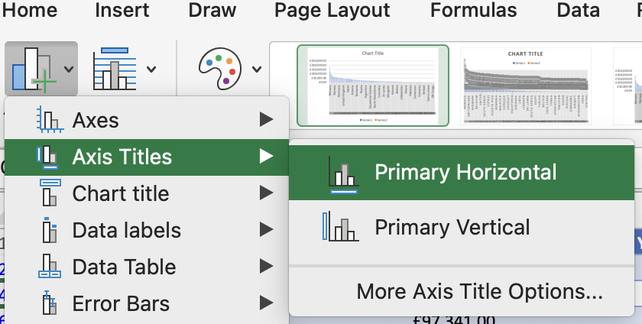

d) After selecting “Primary Horizontal”, the chart creates an “Axis Title” text box that I can now rename “Countries and Rank”.

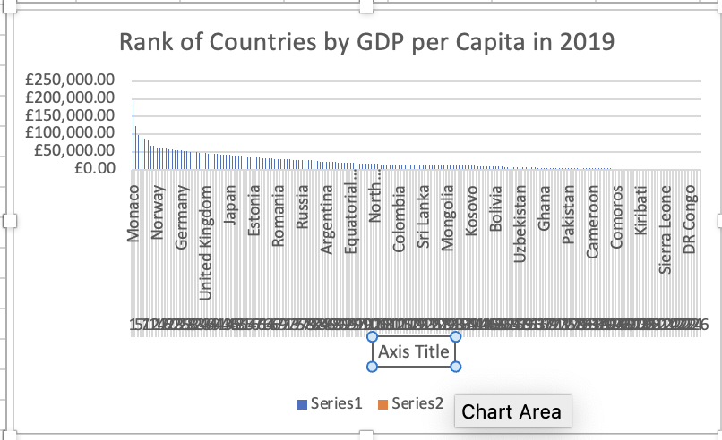

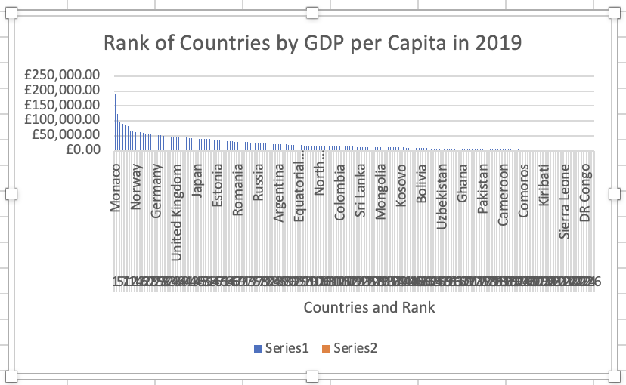

e) I repeat the above steps with “Primary Vertical Axis” and rename “GDP Per Capita (PPP)”.

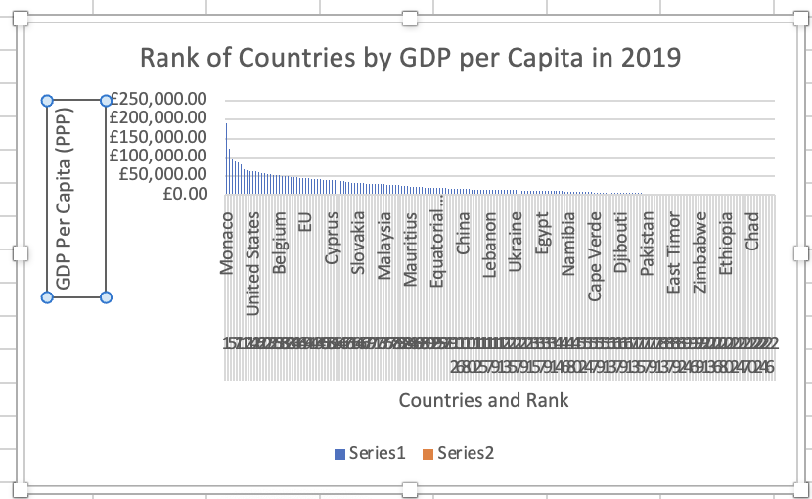

f) After entering title and axis labels for the column chart, the chart now requires amendments to make the chart presentable and understandable, firstly move the cursor to the corner of the chart and drag accordingly to increase the size of the chart to increase the visibility of the X axis country information.

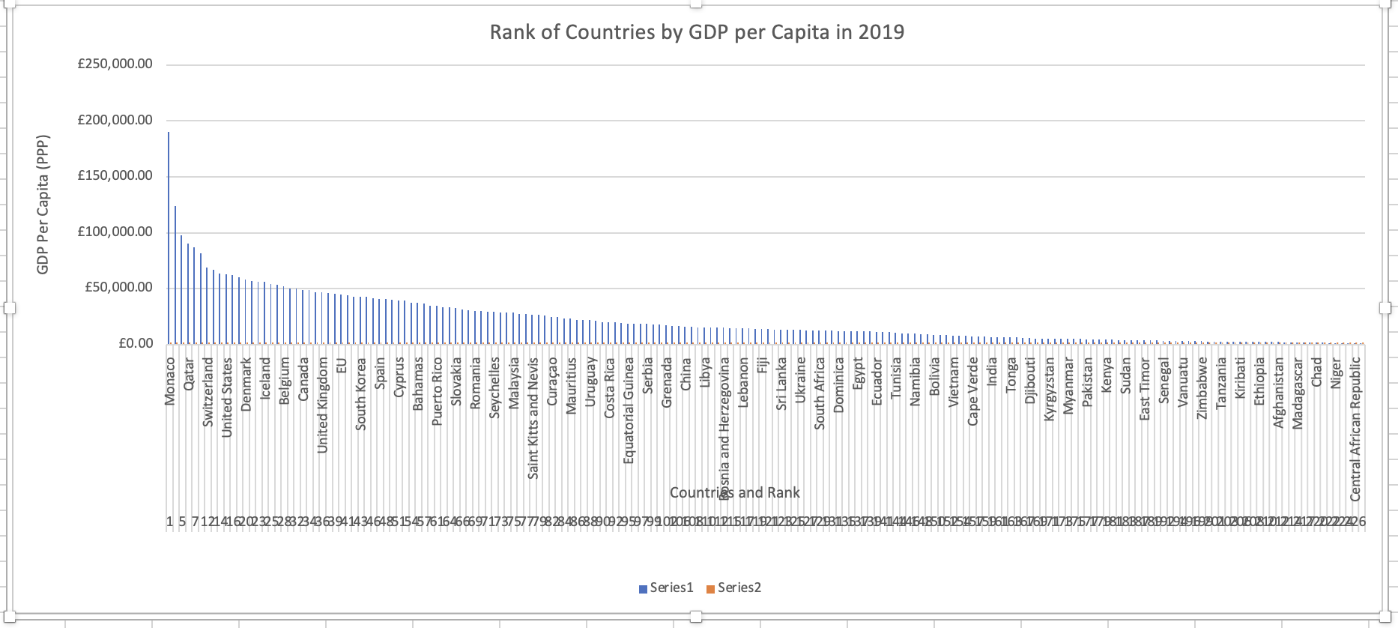

g) Next to edit the overlapping rank information in the X axis, right click and select “format axis”.

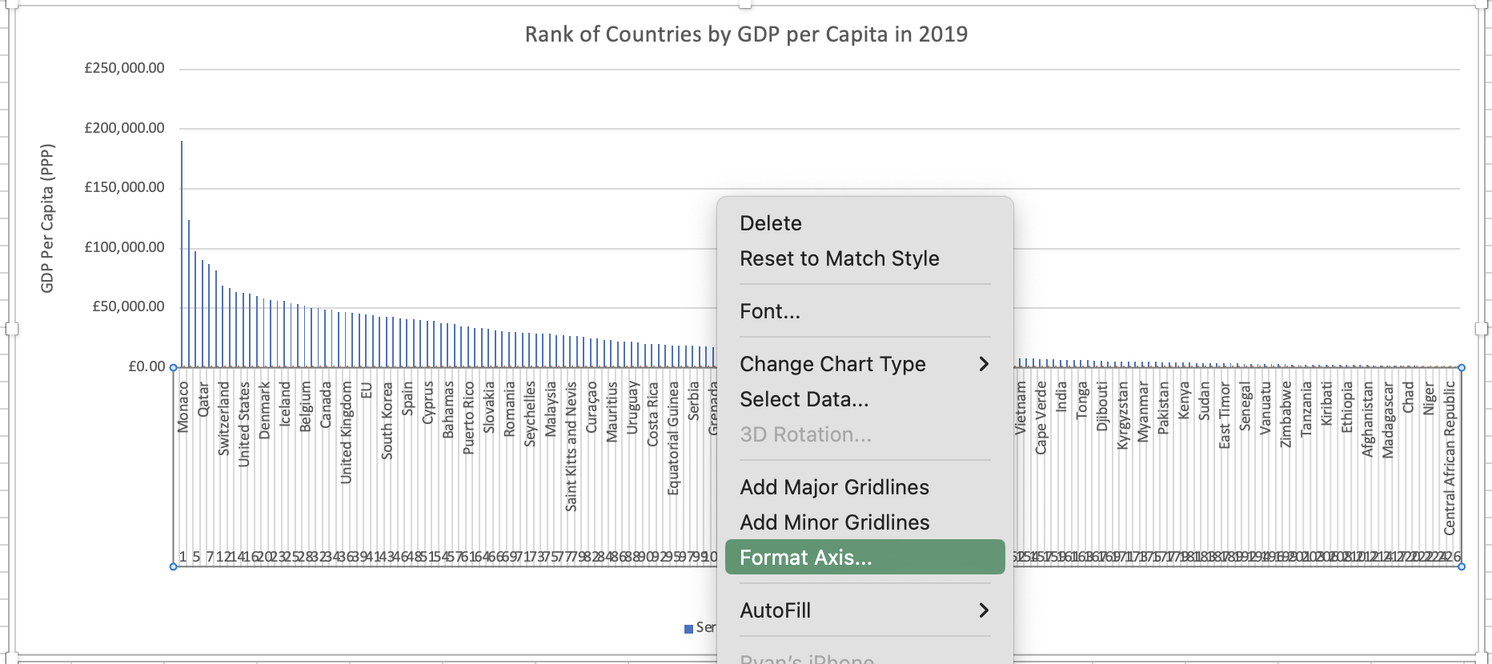

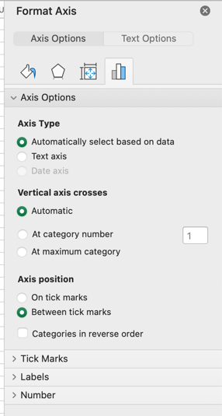h) Selecting “Format Axis” will bring up a table on the right with options to edit your chart further. The first thing I’m going to do is help unscramble the Rank information at the bottom of my X axis. To do this I will select the “Labels” dropdown under “Axis options”.

i) After opening the “Label” options I am presented with the option to customise the intervals between labels, using this function will allow me to reduce the visibility of some of the country and rank data that isn’t helping the chart make sense of what we are trying to visualise. Currently the interval between labels is set to “Automatic” I will select below it to “Specify Interval Unit”.

I can now enter a number in the box to introduce a gap between units (Countries) being highlighted where it may best visualise a gradual drop off in Countries GDP performance. As per the below example:

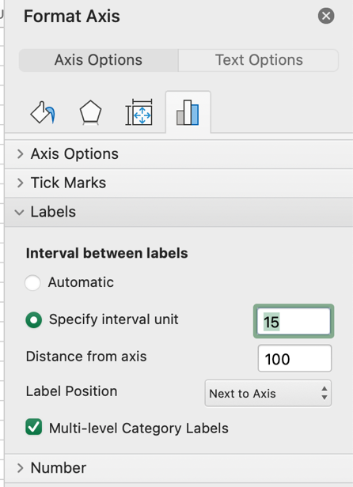

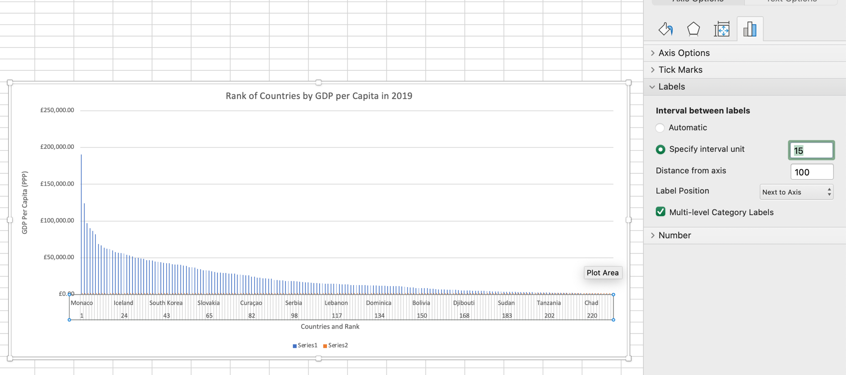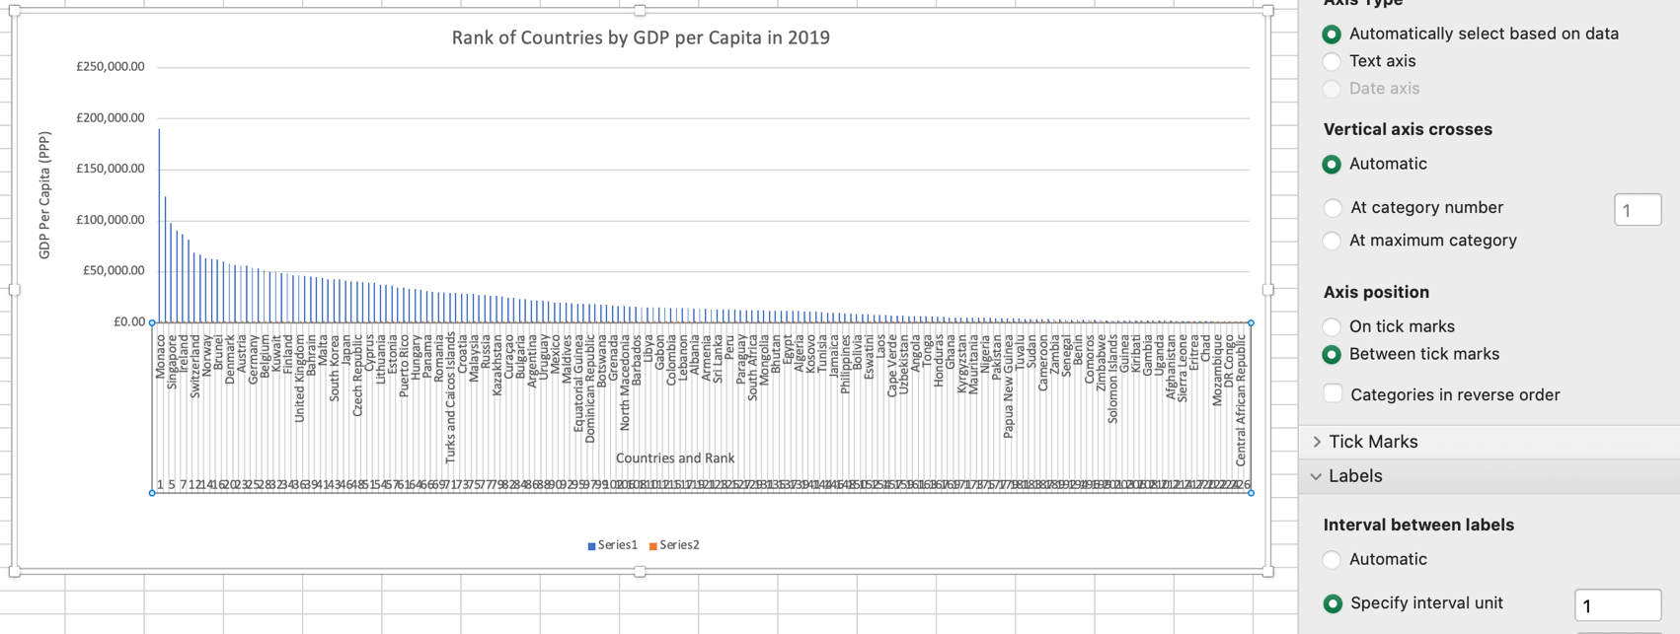

By amending interval unit from 1, to 15. The display on the X axis is attuned to reduce labelled countries and rank to a more understandable visual, whilst still maintaining the trend in recorded GDP across nations. The GDP for all nations in the chart can still be accessed by hovering over individual lines in the plot area.

j) While in the labels tab I can also improve the visual appeal of the chart by deselecting “Multi Level Category Labels” doing this removes the grey line effect around the countries data, and applies a consistent white background instead that blends better alongside the rest of the chart.

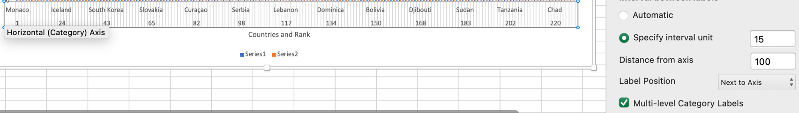

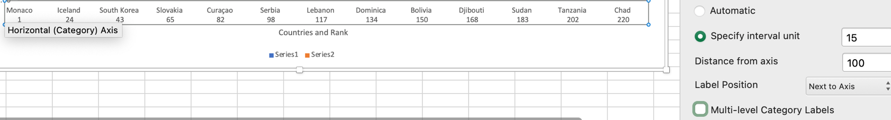

k) I decide that this specific chart does not require a legend to make further sense of the chart, and in fact is a distraction from the data story we are telling. So I remove it by selecting the legend text defaulted currently as “series 1” & “series 2” and deleting.

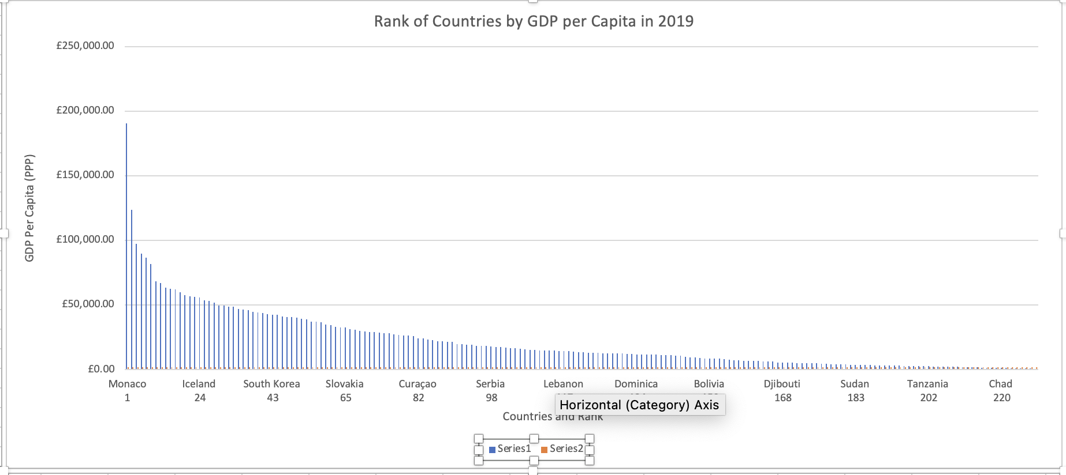

l) I decide to apply a template effect to stimulate the visual appeal of the chart, this is done by using the “Chart Design” ribbon and selecting one of the available models for your chart effect. I feel the one below best emphasizes the axis labels combining the three data points we have highlighted, whilst using darker colours to communicate the flow of the individual data and specifically the outlying spike for the top ranked country for GDP in 2019, Monaco.

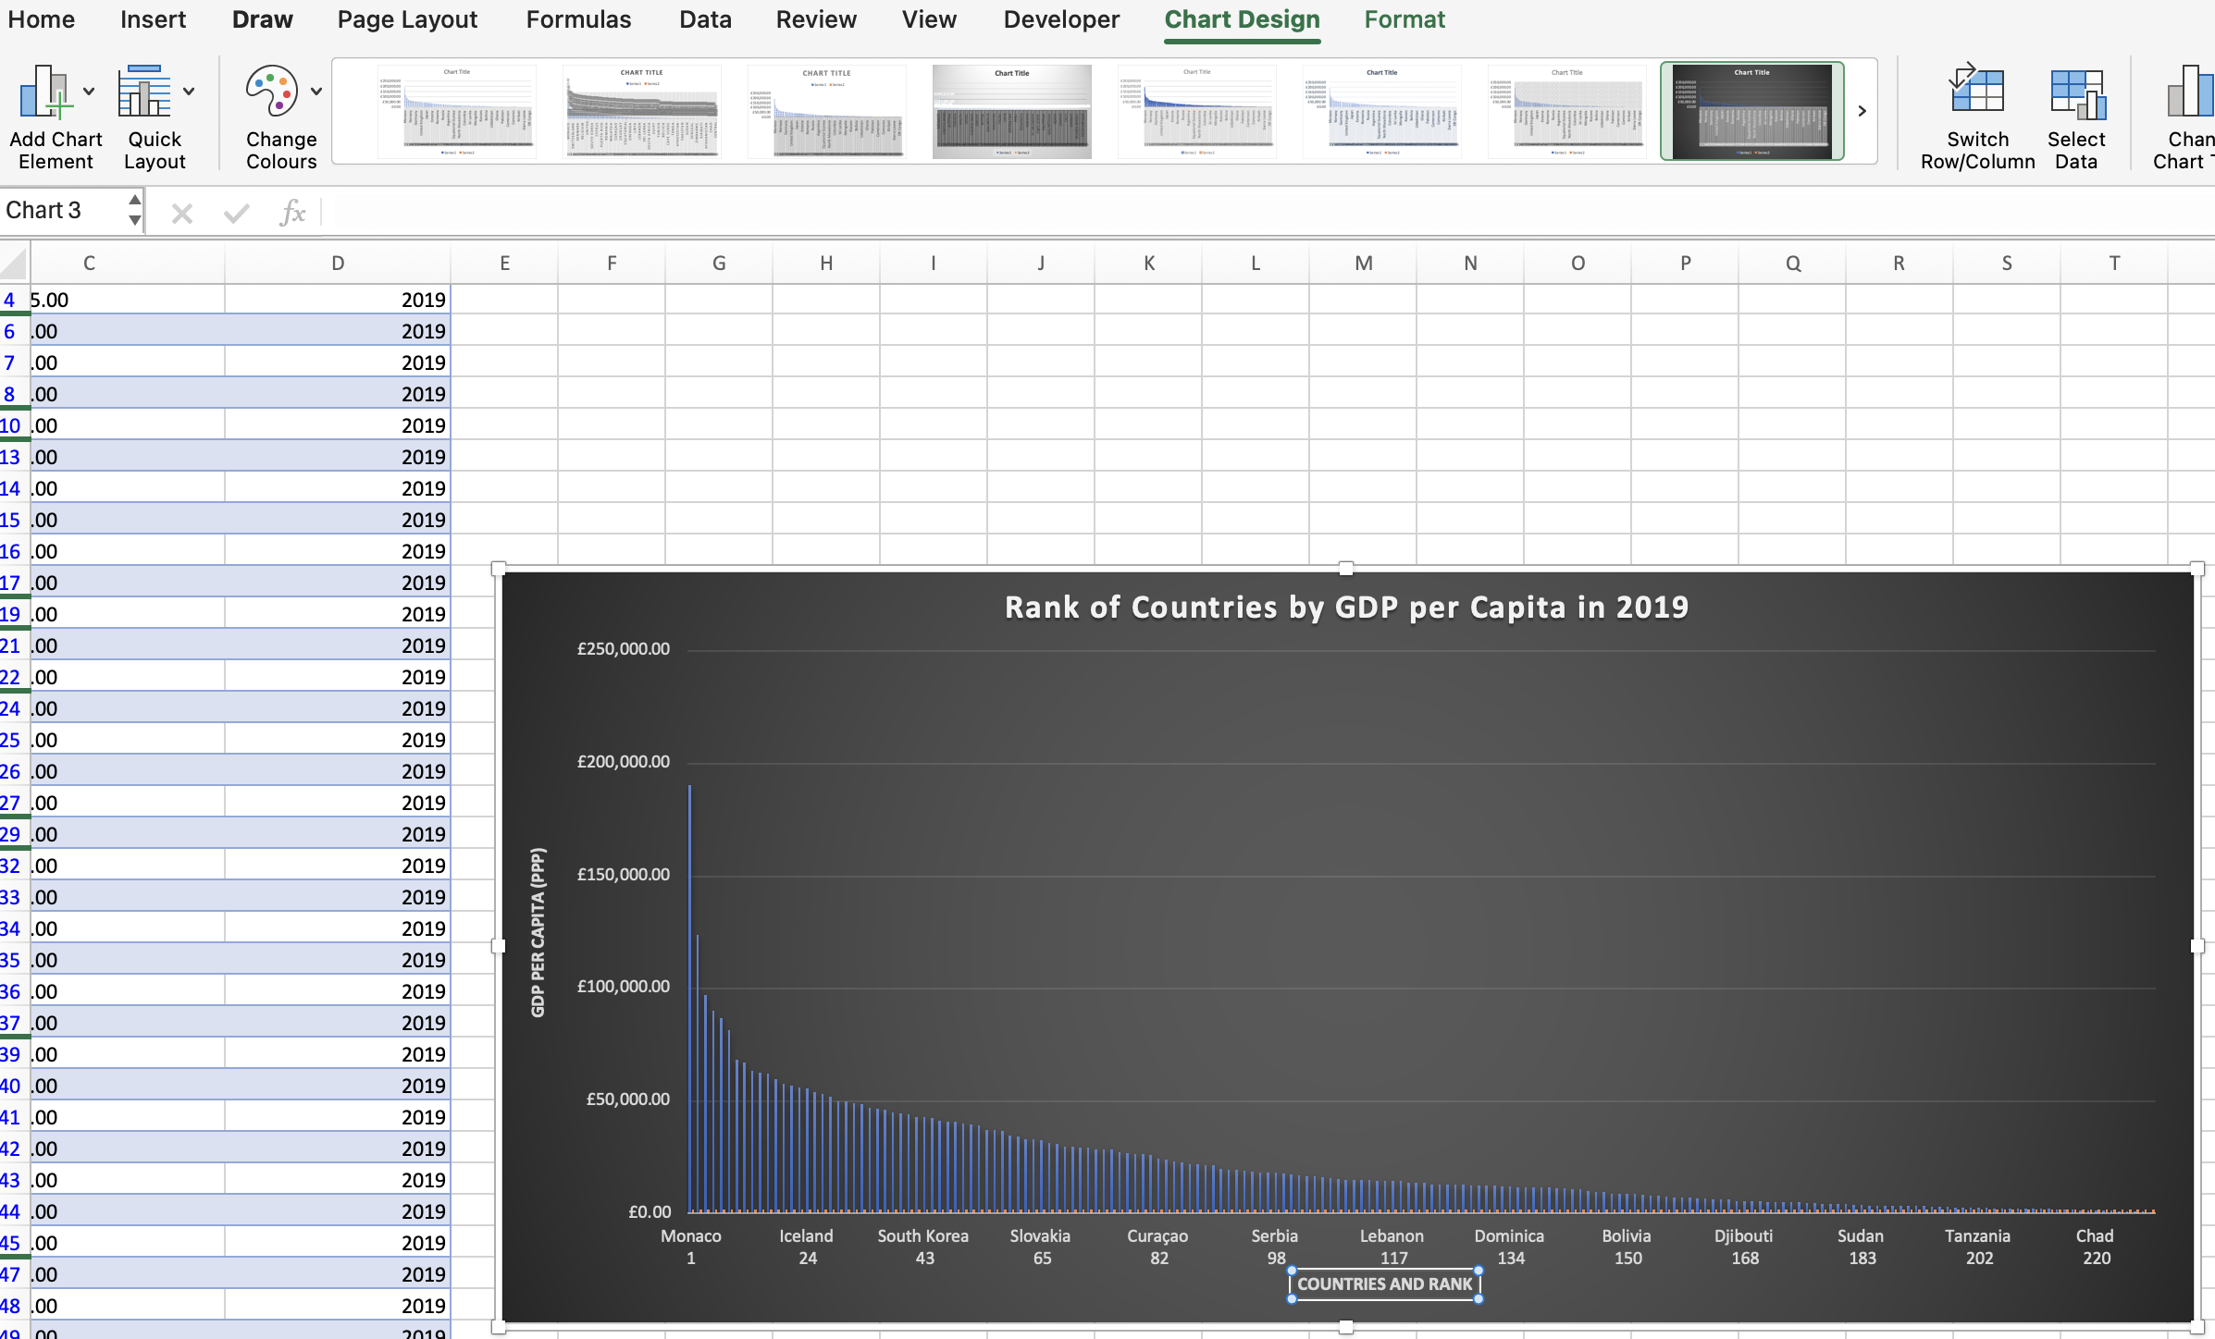

### Move the chart to a new sheet tab and label with a suitable name.

a) I first create a new worksheet by selecting the + icon next to my existing worksheets.

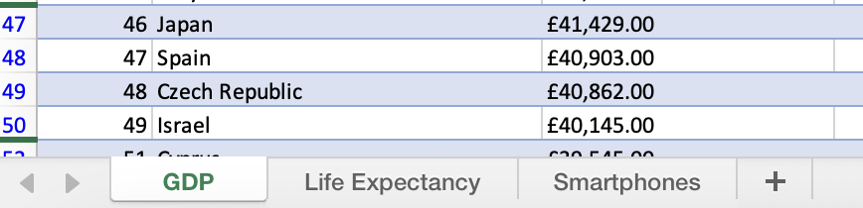

b) I rename the new sheet to “Column Chart for 2019 GDP”.



c) I then return to my GDP sheet, right click my column chart and select “Move Chart”.

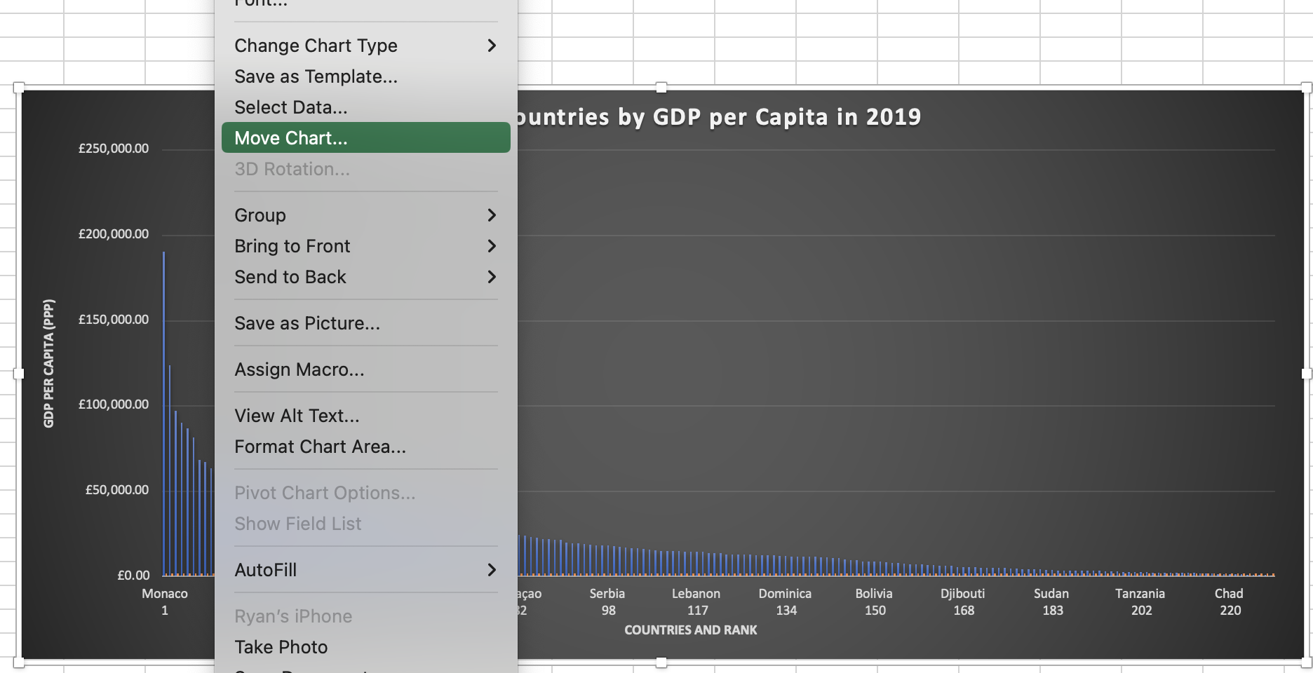

d) From the options I select to move chart to my existing worksheet by selecting “Object in” and Column Chart for 2019 GDP from the drop down box and select Ok.

e) My chart is now correctly situated in my new worksheet.

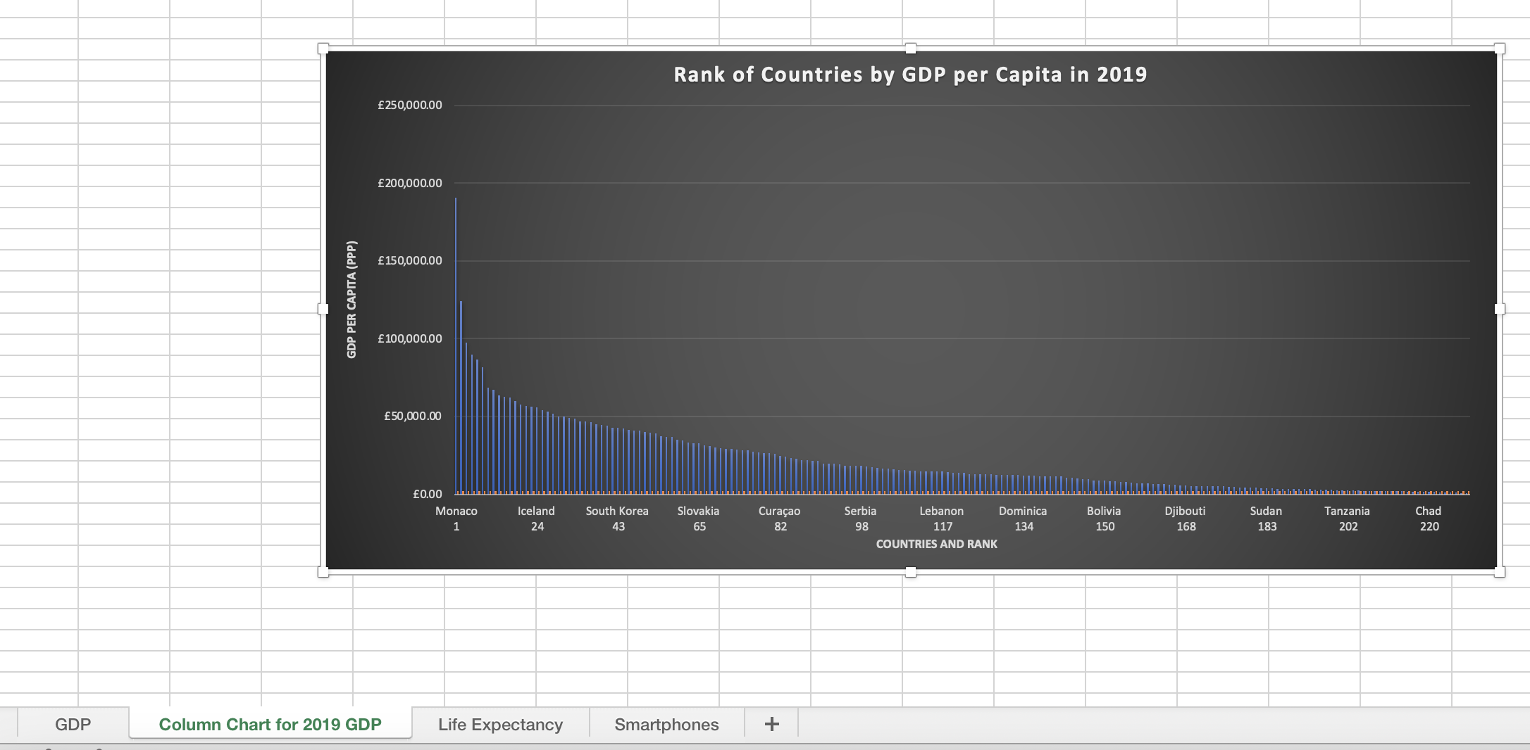

### Create a sort for the top 20 highest ranking countries.

a) I will return to original table and select the drop down filter for Rank.



b) From the following box select “Ascending” and deselect “Select All”

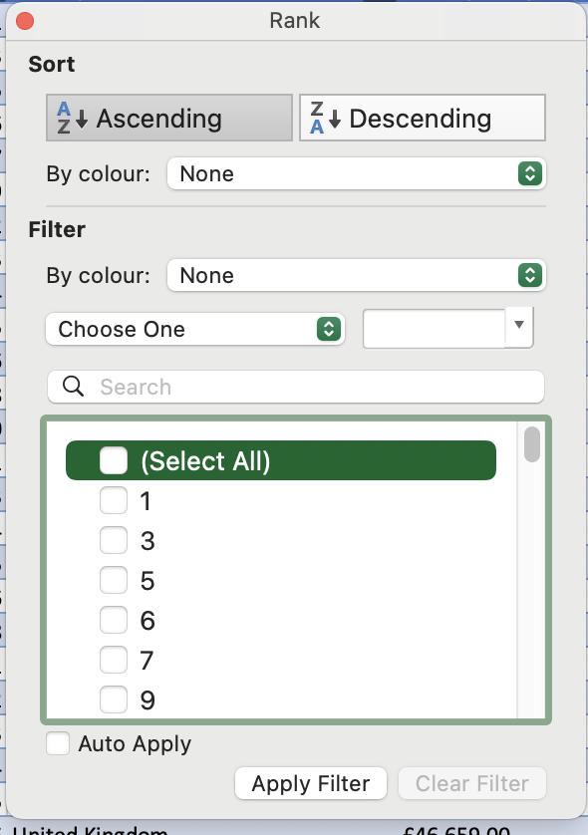

c) Now I will select just the top 20 numbers which associate to the Top 20 ranked countries in my table. And select apply filter.

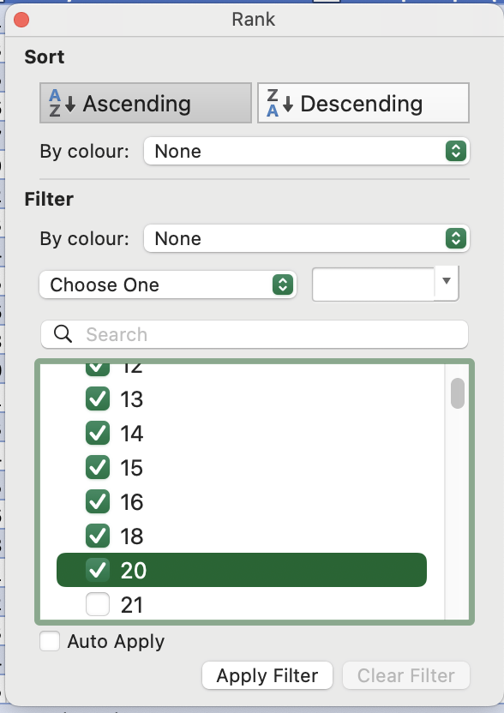

d) The table has now been sorted to display just the highest ranking 20 countries.

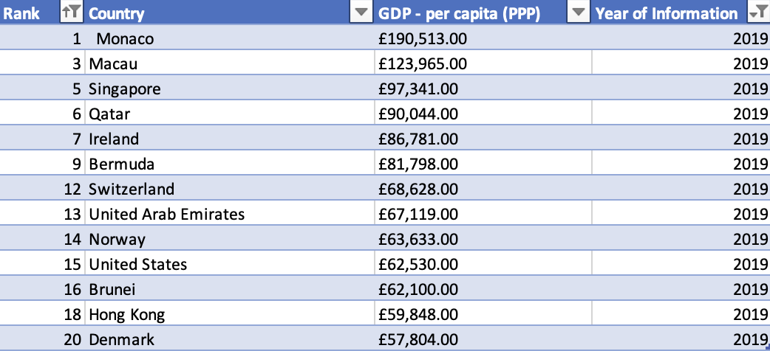

### Creating bar chart to to display the highest ranking 20 countries from my sort and placing it under the table.

a) First I will group select Rank, Country and GDP.

b) As before with my original chart, I will select “Insert” ribbon and use the chart drop down to select 2-D Bar chart

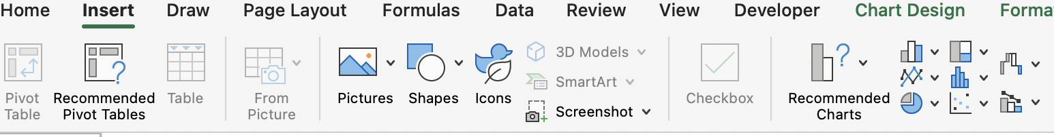

c)

The bar chart will require a new chart title, I amend this to “GDP Per Capita (PPP)”

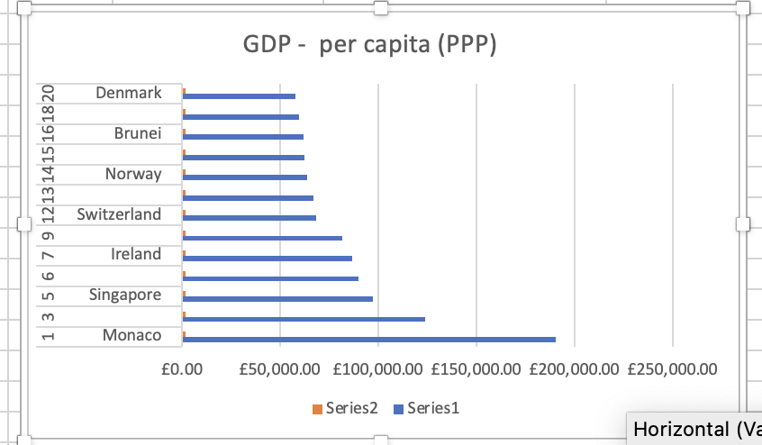

d) With this chart I will use a legend to identify GDP per capita. I right click the default series legend and from click “Select Data” from the table.

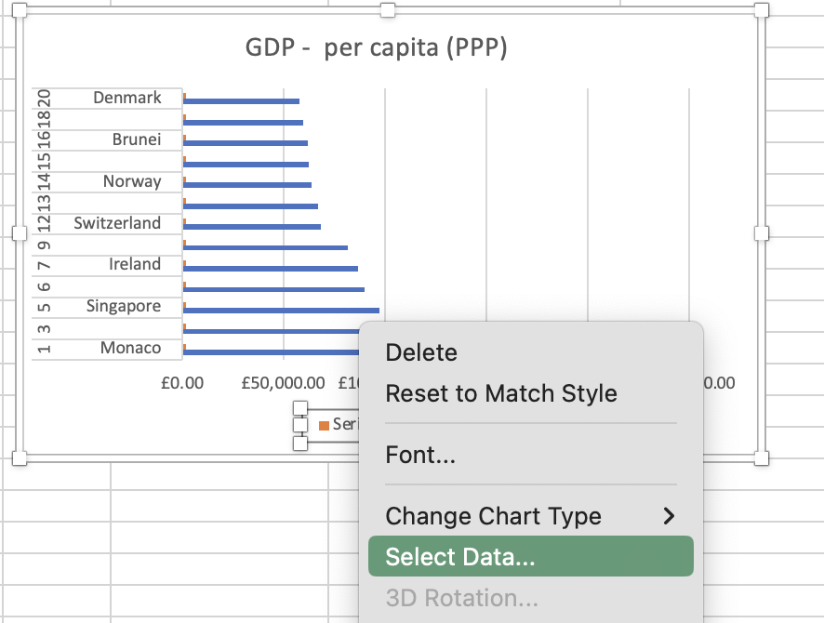

e) On the following screen I will amend the dialog box for “Series 1” to read “GDP per capita (ppp). And I remove “Series 2” by selecting the – sign beneath the Legend entries box. Once complete I select Ok.

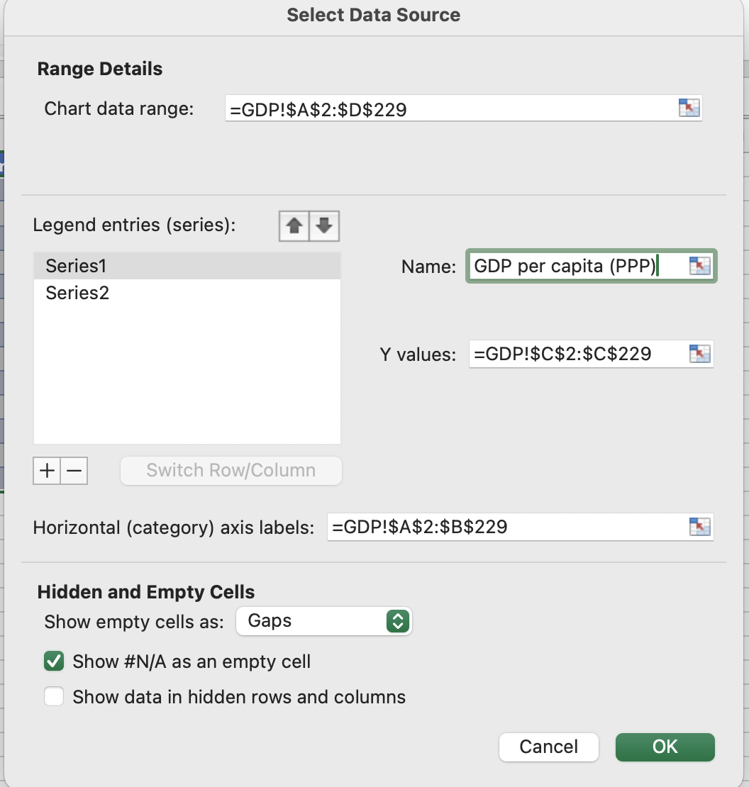

f) Now I will move the bar chart beneath my table to display the two separate visual representations of the top 20 ranked countries by GDP.

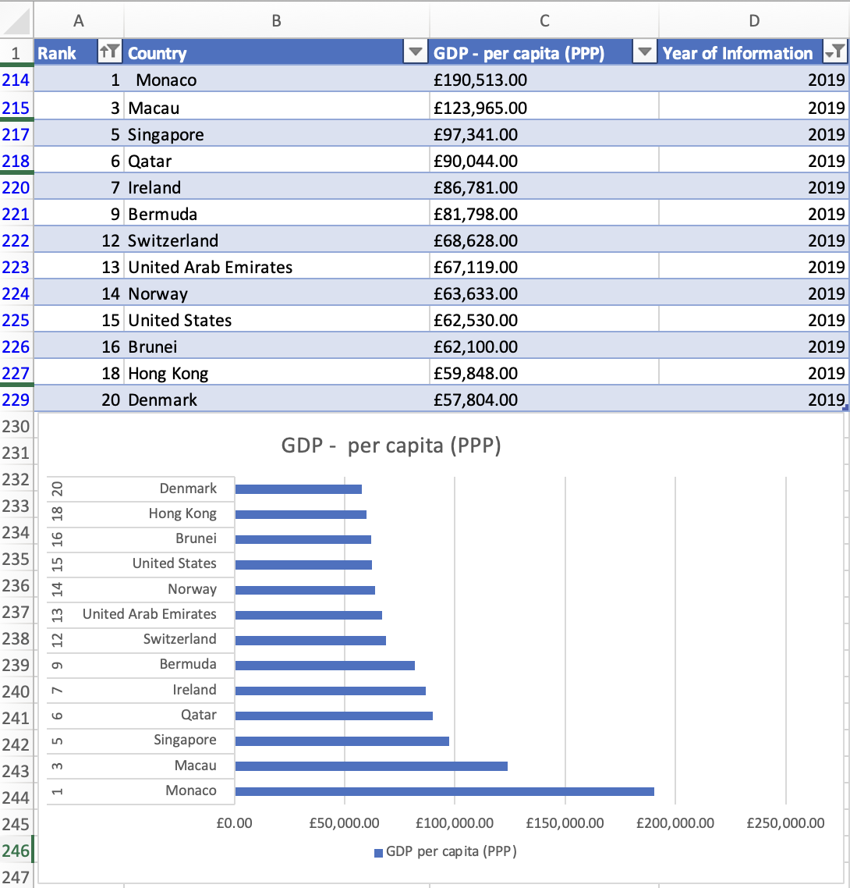

### Colouring the background and Highlighting the area beneath the table.

a) First I will drag and select the area beneath table.

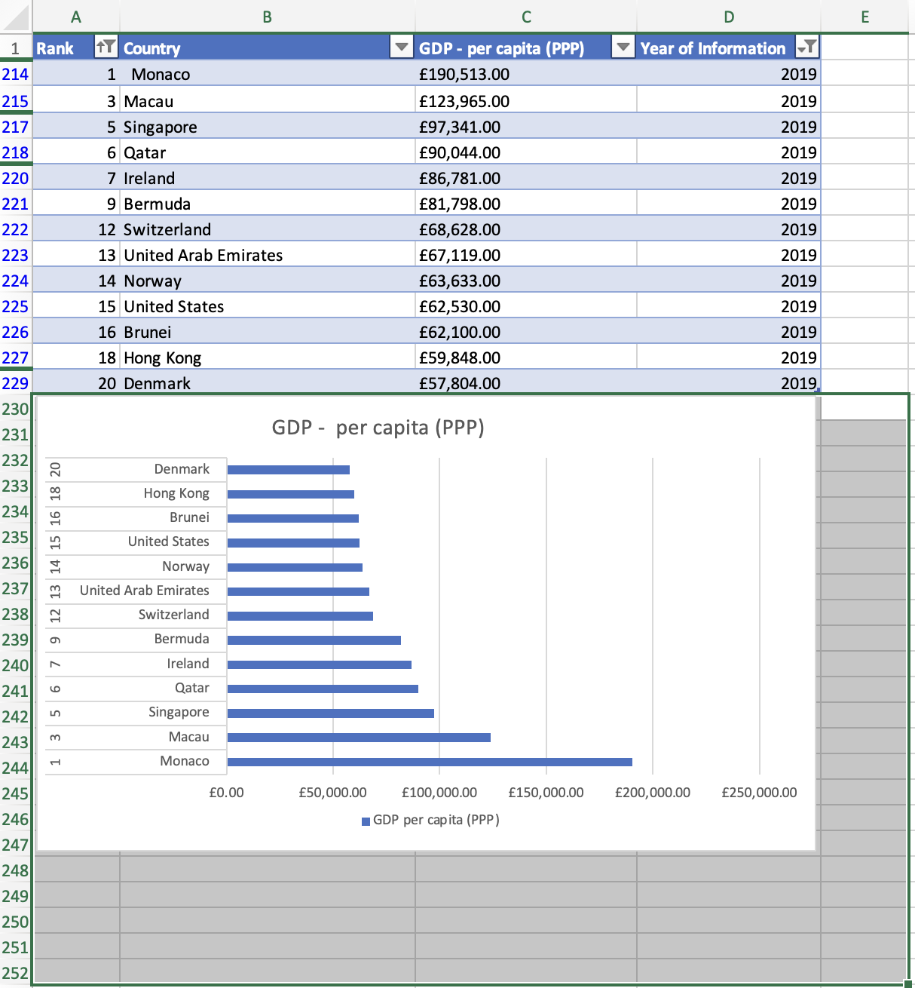

b) Under the “Home” ribbon I locate the fill colour icon and select a green background for my chart.

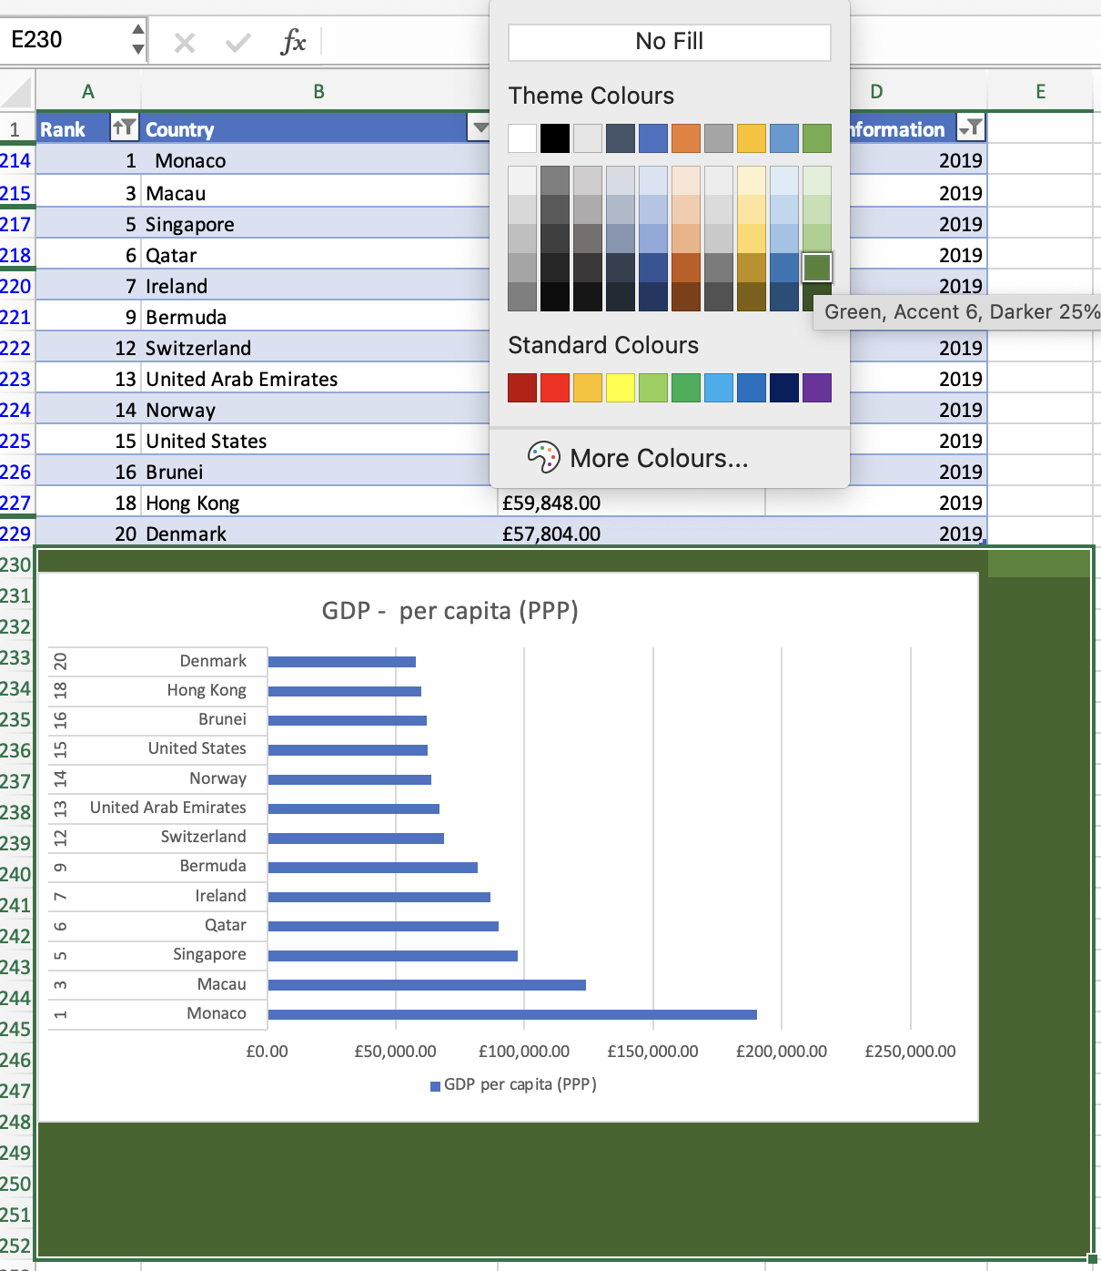

### Creating Macros and Macro Buttons

a) I will begin by creating a Macro to “Print The Sheet”. Firstly I will select the “Developer” tab from my ribbon and from there select the “Record Macro” option.

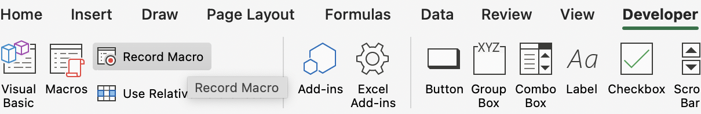

b) On the next box that opens I will name my Macro, assign it to the existing Workbook and designate a shortcut command to run the Macro as well as giving the Macro a description of the action it will perform.

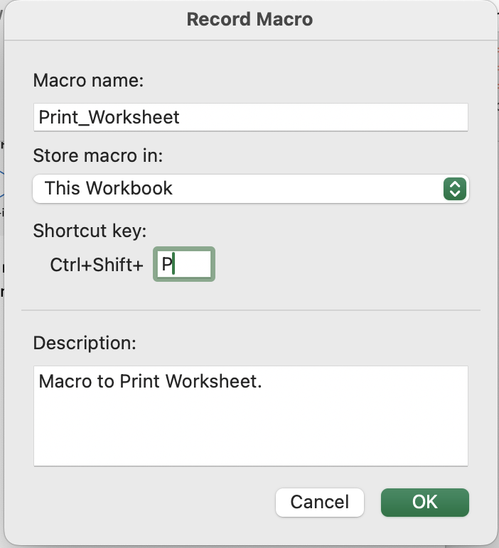

c) Select “File” and scroll down to “Print”

c) 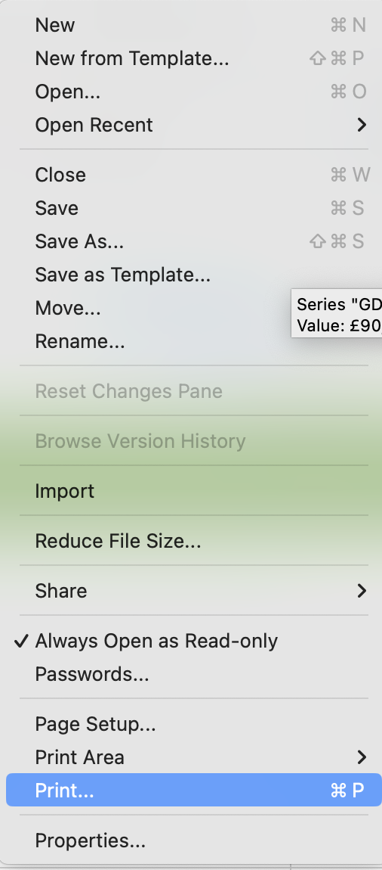

d) I select to only keep the range from page 1 to avoid printing an unnecessary second sheet with no valuable data. And select “print”.

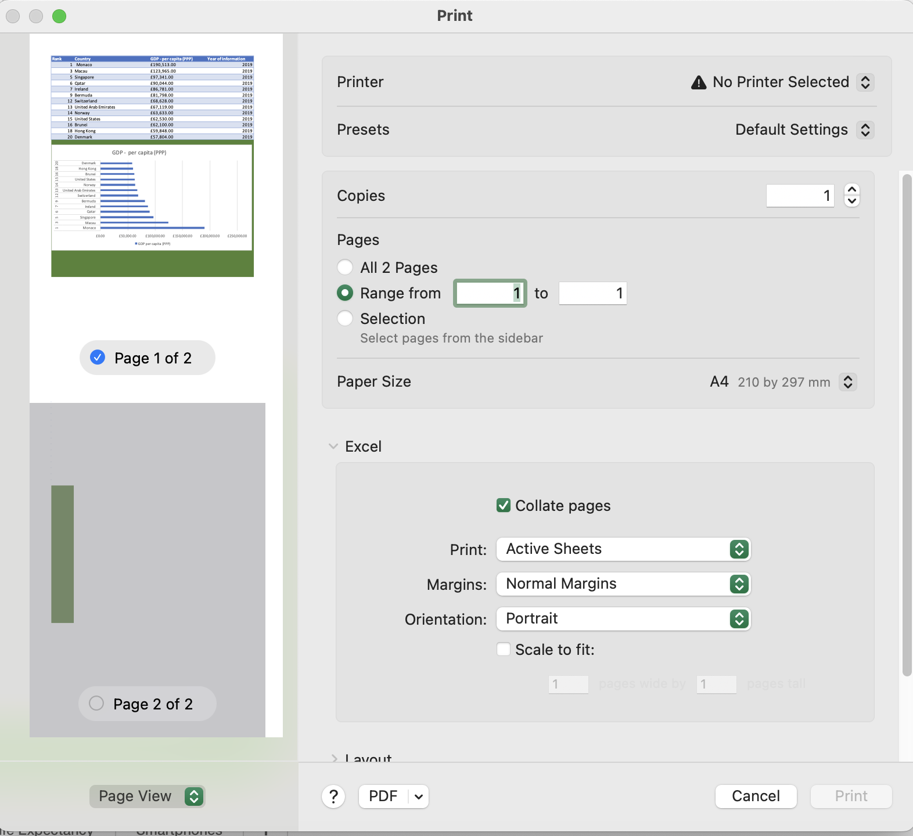

e) To end the Macro I select the “Stop Recording” option found where “Record Macro” was previously. My Macro can now be located when I select the “Macros” option in future and to perform the “Print” action I would select “Run” on the following page.

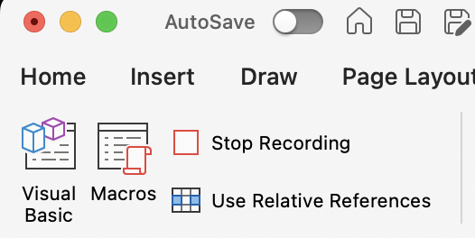

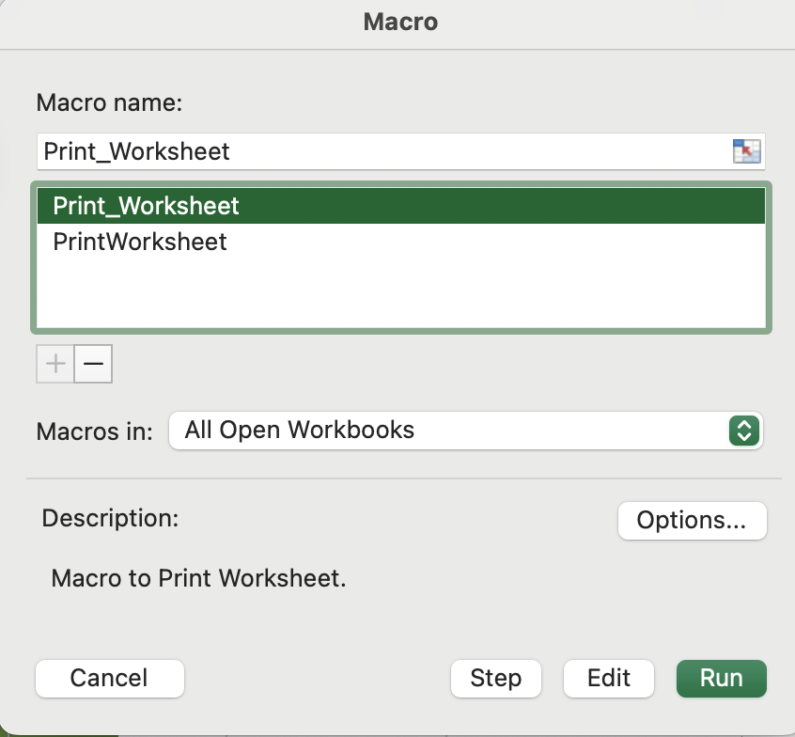

f) To create the “Save The File” Macro I will as previously demonstrated with the “Print” Macro, select the “Record Macro” option under the “Developer” ribbon and in the corresponding box record a suitable title “Save_the_file” store in this workbook and designate a short cut command prompt before selecting Ok.

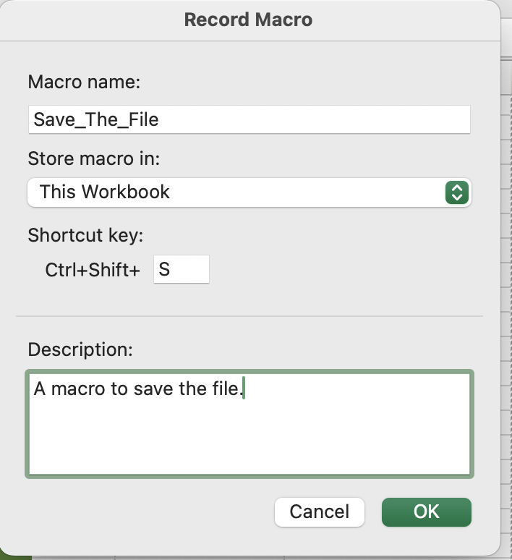

g) I select “File” as before and choose “Save” from the menu.

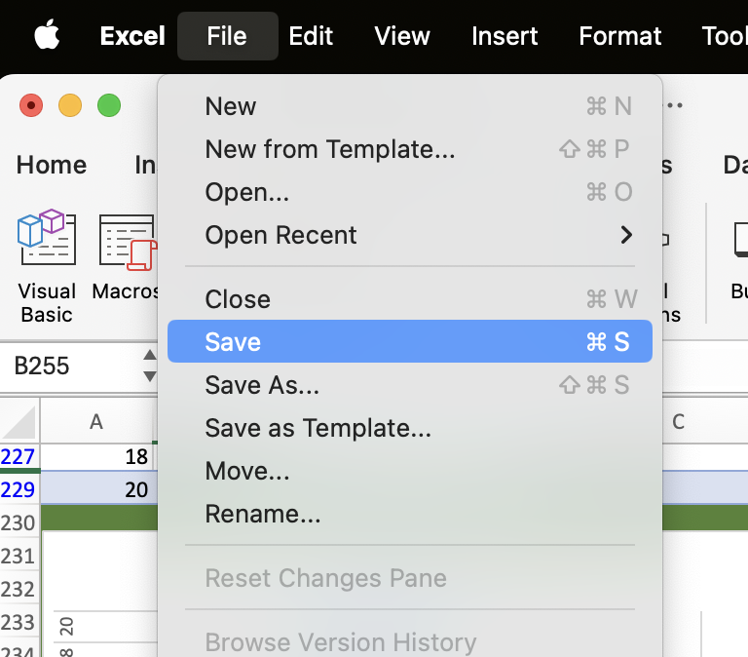

h) I am met with a box requesting me to save the file as a Macro-enabled file in order to proceed with completing the command set up. I click No as instructed and then proceed to amend the file type to a Macro enabled format before completing the save.

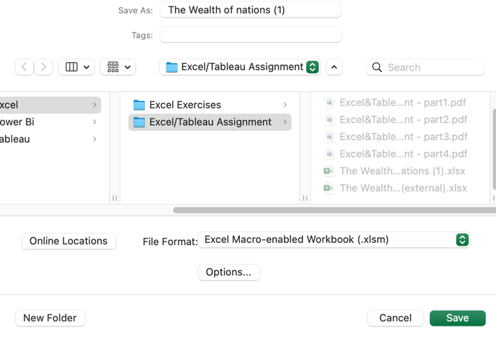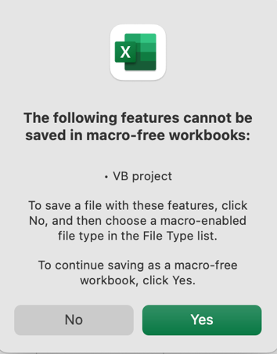

i) After I stop recording the macro and open “Macros” from the ribbon I now have “Save_the_file added.

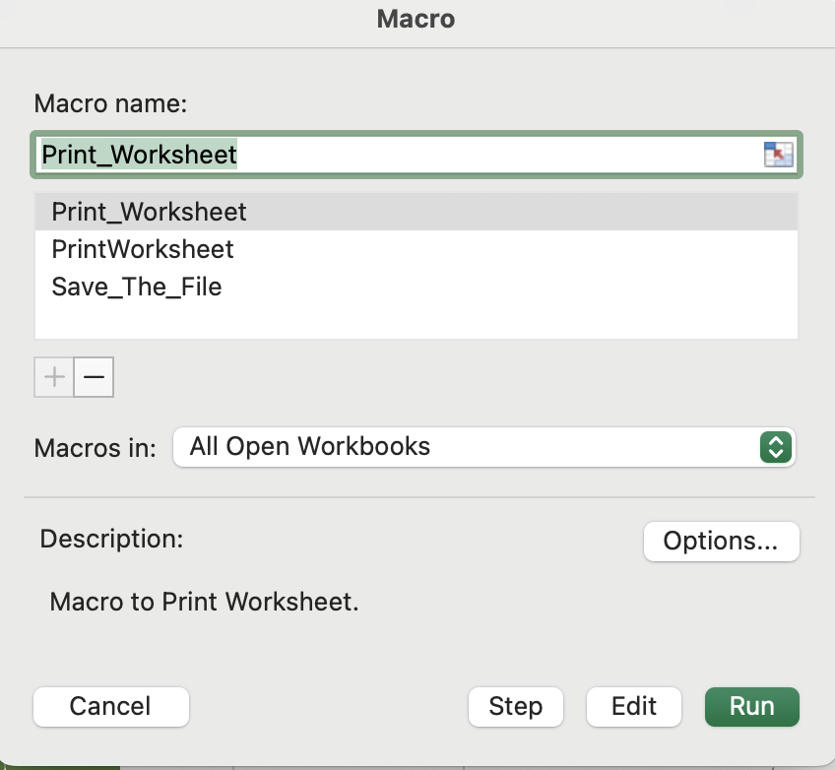

j) My last macro to create is “Copy_The_Sheet” I select Record Macro and complete the corresponding details as per the same process as the last two Macros.

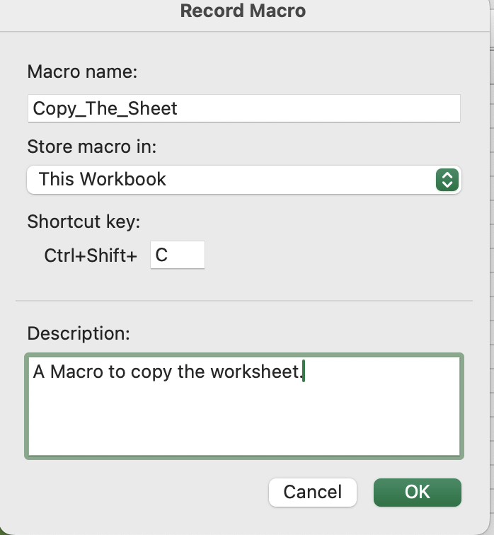

k) I will then select the entire worksheet by using the box at the top left of the worksheet and clicking. And then right click on sheet and select “Copy”, And then “Stop recording”.

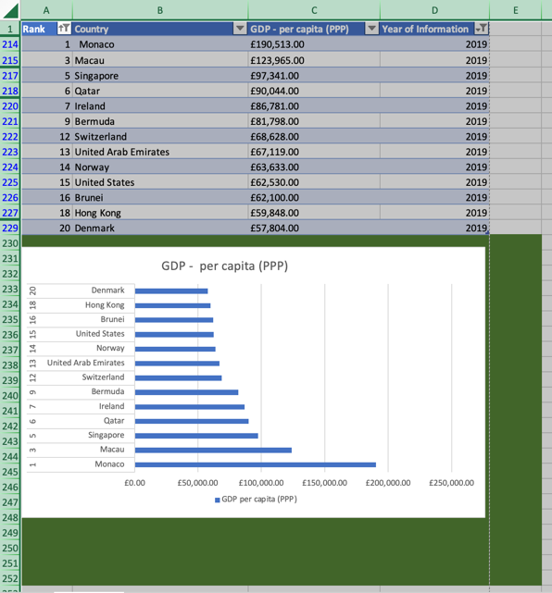

l) Now that my three Macros have been created, I will now create and assign them to buttons for future use from the worksheet itself. Firstly I will select shape option under the “Insert” ribbon.

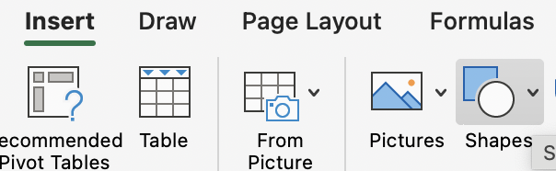

m) From the drop down option I select my three separate shapes for each Individual button and proceed to use the cursor to create the shapes.

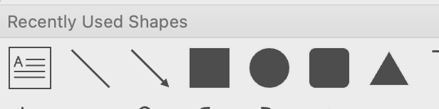

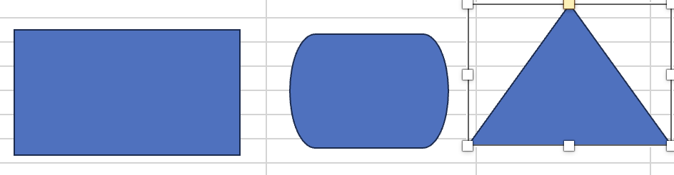

n) I then right click my shapes individually and select “Edit Text” to begin naming them.

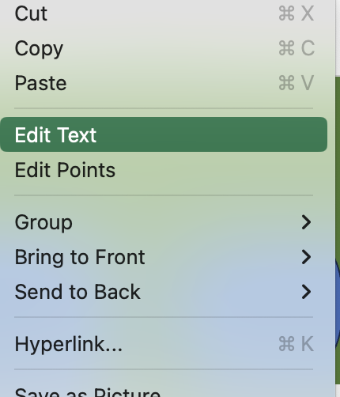

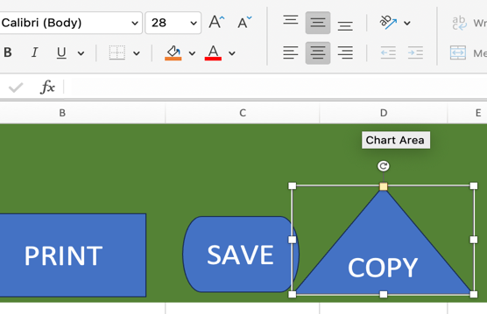O) After naming the buttons I then adjust the font and size as well centre the text via the options presented in the ribbon.

p) To then assign the macro to the button, I will right click my button and choose the “Assign Macro” choice from the menu. From the next box I select the previously created Macro from the list available and select Ok.

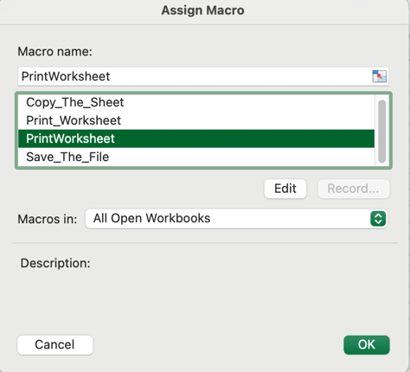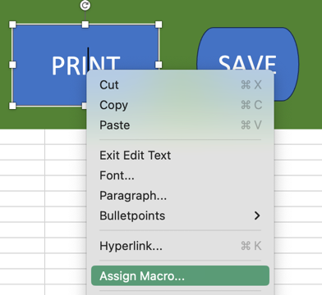

### Copy The Worksheet Using The Macro.

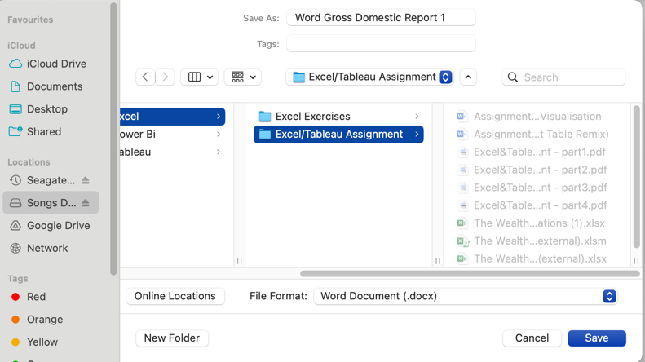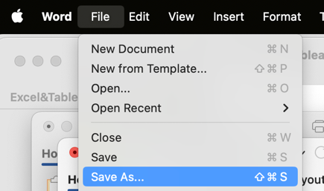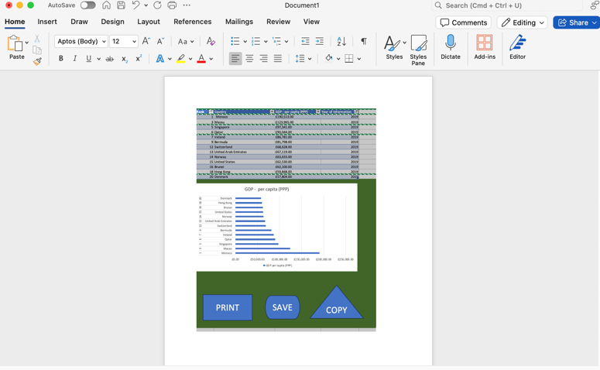After assigning my macros when I now hover my cursor over the buttons, the cursor changes to a hand to signify that the button has been assigned a macro. When using the “Copy” button it performs the assigned macro and the resulting copy can then be pasted into a new word document and saved as word gross domestic report 1.

### Adding Headers and Footers.

a) I first select the “View” ribbon, and under that I open the page layout icon.

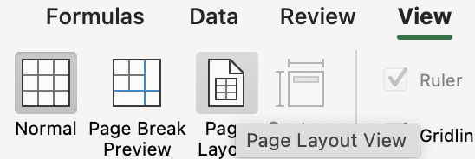

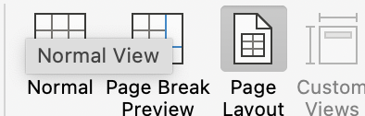b) From here I am able to add my name and GLA data 1 into the header tab. And the date, assignment title and module into the footer tab. After I can return to the normal view via the option next to page layout in the ribbon.

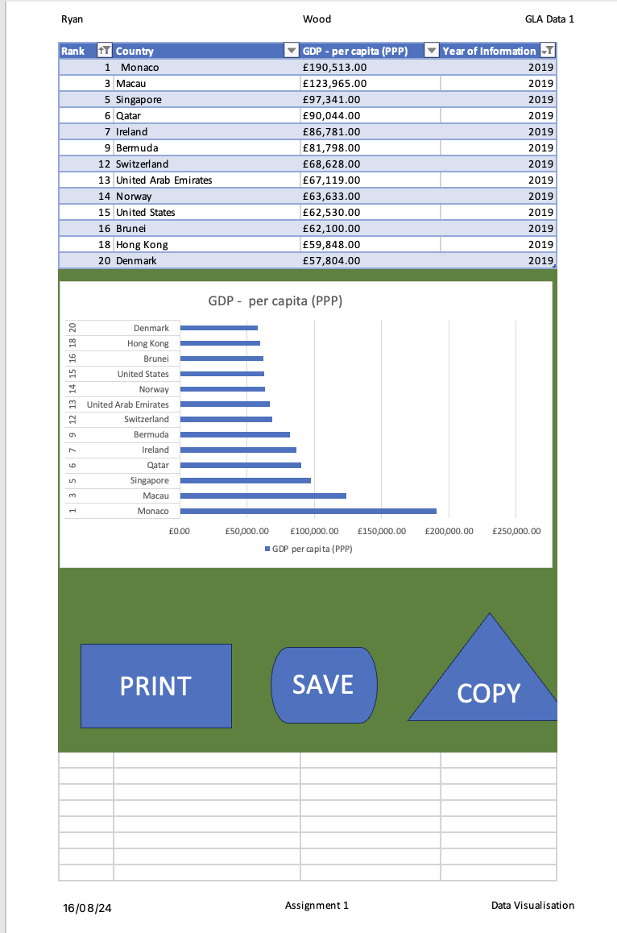

### Save Excel Document as ‘Excel Gross domestic product report 1’

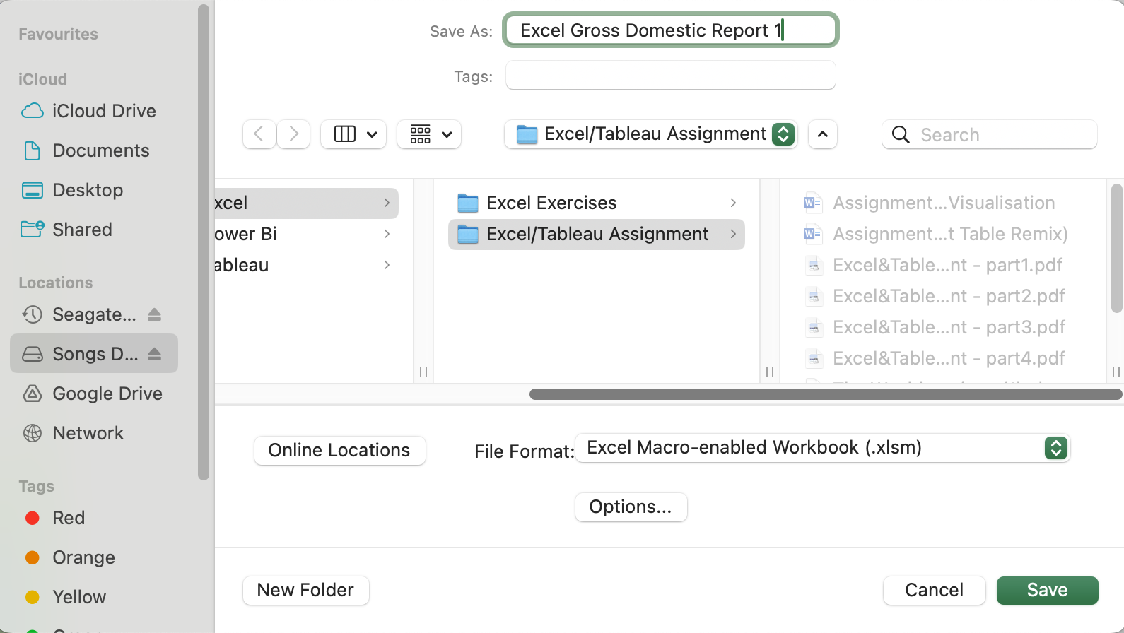

## Tableau

# Import Data

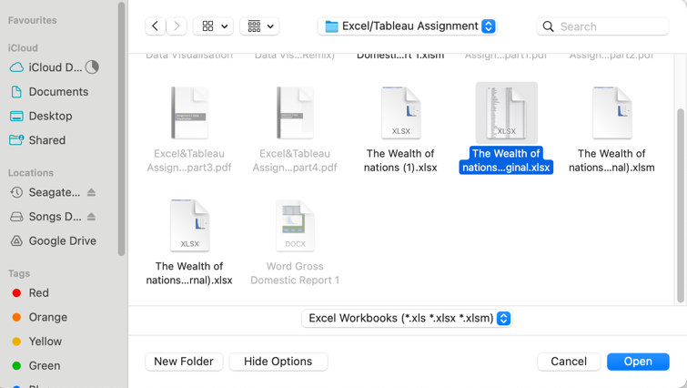To begin importing my data to Tableau for further analysis and in order to create my clients visualisations, after opening Tableau I will select Microsoft Excel from the “Connect” pane on the left hand menu. And then open the Wealth of Nations excel file.

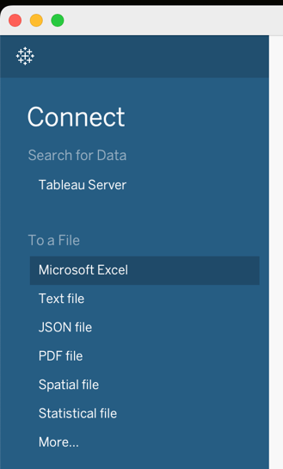

# Set Relationships

a) In order to connect my data across my excel workbook and format it for making insights and future dashboards on Tableau I will first set relationships between the saved worksheets. To do this I will begin by dragging my Excel worksheets found under the sheets tab on the left of the connections page, into the central pane.

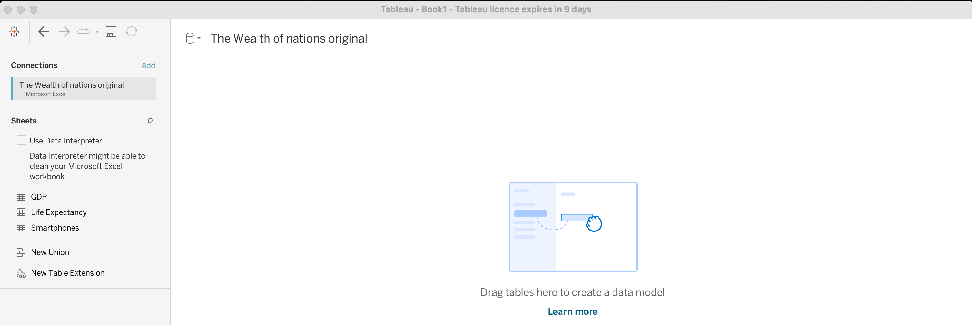

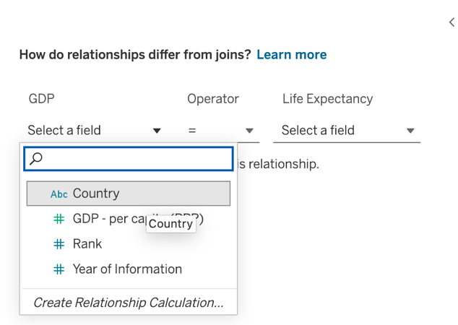b) After dragging “GDP” and then “Life Expectancy” into the central pane, I am met by an alert that the sheets need a “relationship” (e.g a common column shared by both sheets) to make a successful connection across work sheets. To provide this relationship I “select a field” as indicated. And following that select the option of “Country” given to me by tableau as a possible relationship. I repeat this process with the Life Expectancy field and keep the “Operator” as = symbol between both sheets.

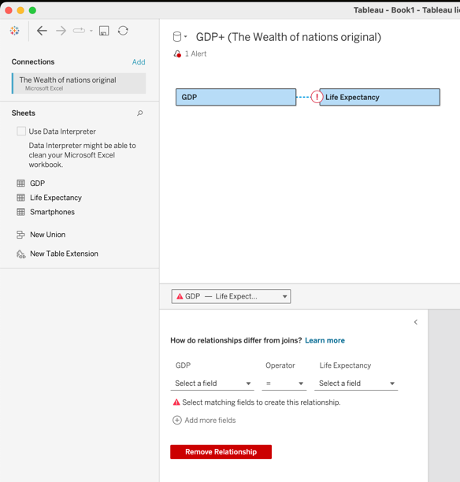c) After completing this step for all three sheets, the connections central pane now displays completed connectors in a straight line.

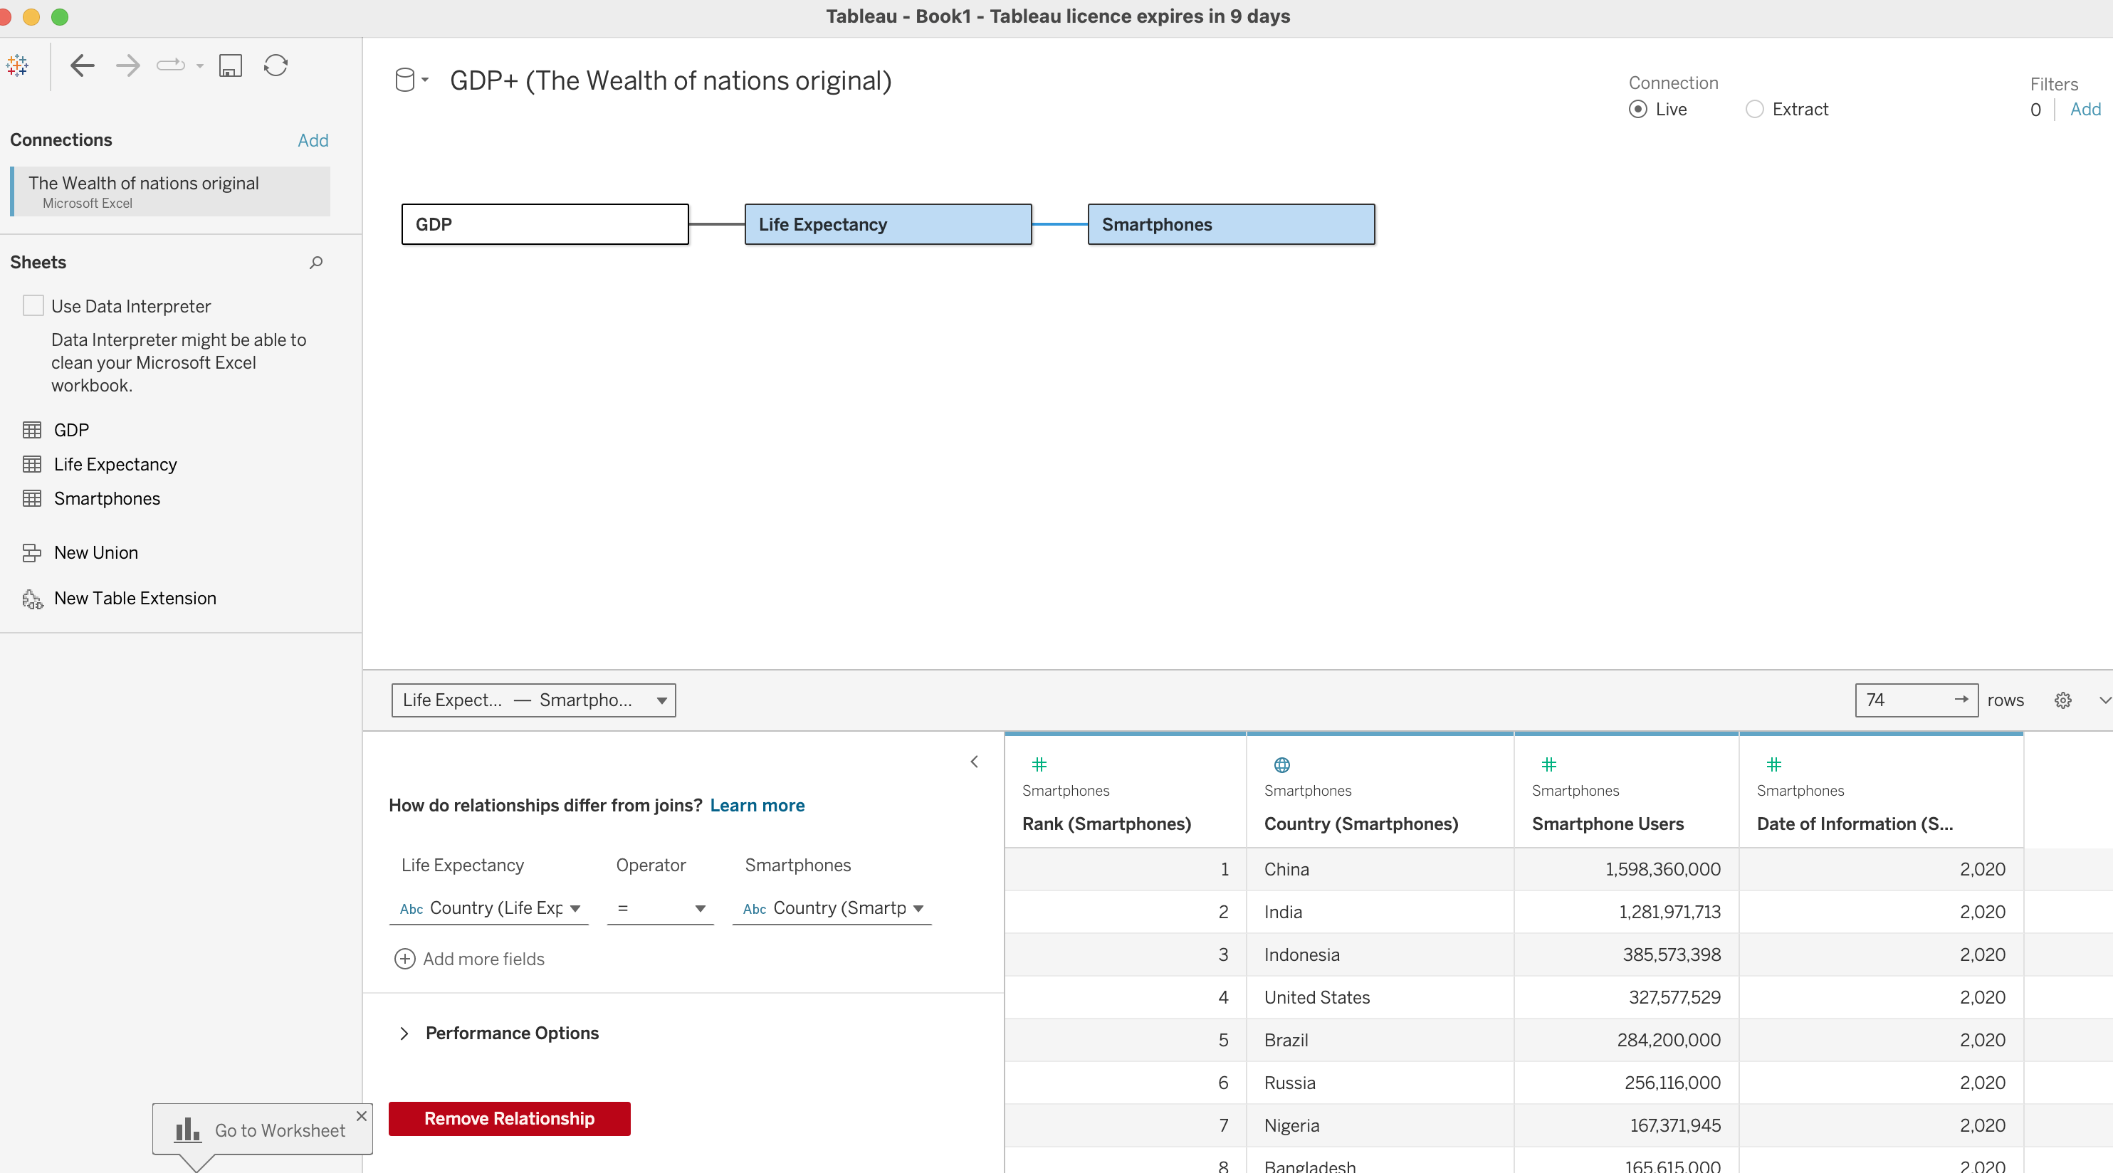

# Check Data Types

a) Having set my relationships I will next check my data types, this is important to ensure that the format of my data is in the right state before I can begin making charts in tableau. To check my data types I will begin by selecting “Data Source” from the bottom left of the connections pane.

To the right of this my sheets data sets (columns) will be displayed, by selecting the drop down menu on each column it will be possible to check the data type in use and amend it if Tableau has assigned the wrong data type during the import. In our “GDP” data set, the final column “GDP Year of information” is using “Number Whole” as it’s data type, however it is displaying a comma between the numbers.

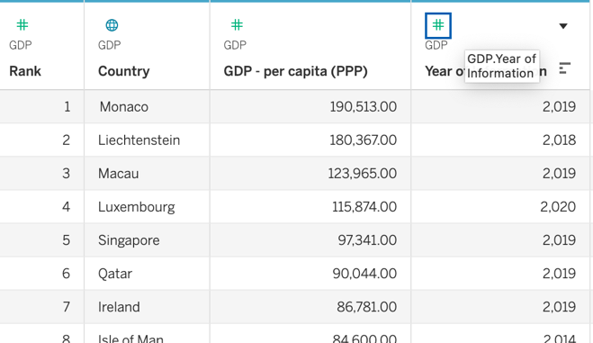

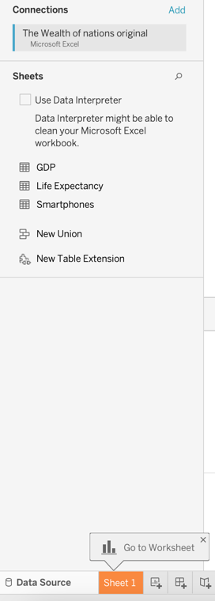

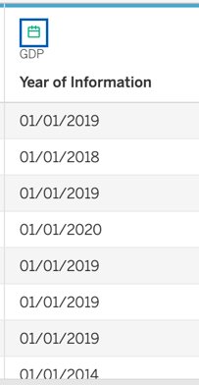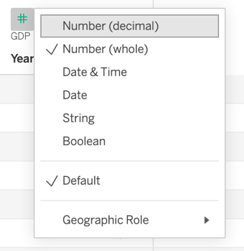b) To correct this, I will select the icon at the top left of the column header, and from the corresponding drop down menu, I will select “Date”. However, selecting this data type includes unnecessary day and month data which our column heading is not specifying. If I return to the drop down and reselect “Number Whole” Tableau will now provide the resulting year without the previous comma.

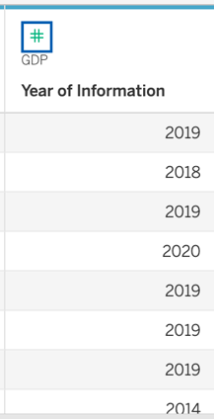

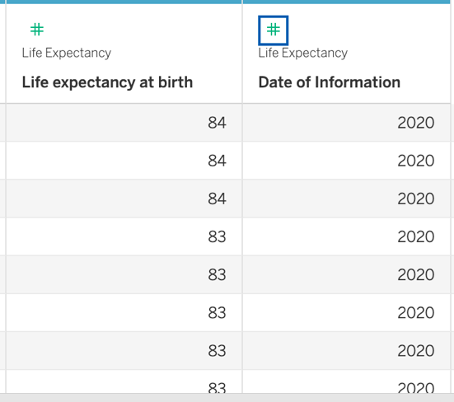c) I repeat this process with the “Life Expectancy” and “Smartphones” sheets, by amending the column for “life expectancy from birth” from “Number decimal” to “Number Whole” and the same steps as previously explained for adjusting the year without a comma.

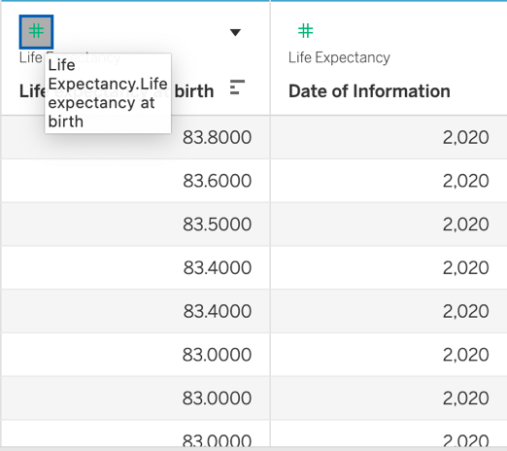

# Build Charts

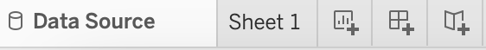a) Now that my data has been connected across my excel file sheets and I have extablished my data types I can begin building charts. To start this phase I will select to the right of “Data Source” and open my first shee t, “Sheet 1”.

b) I am now in the creative hub of Tableau, from this page I can see the three divided spaces for creating and building charts. On the left are my **Tables** containing my imported data sets.to the right of that, my **Filters and Marks** space, and right of that is the **Canvas** where my resulting chart builds will be displayed. Just above the canvas sits my **Rows and Columns** fields, effectively the X and Y axis.

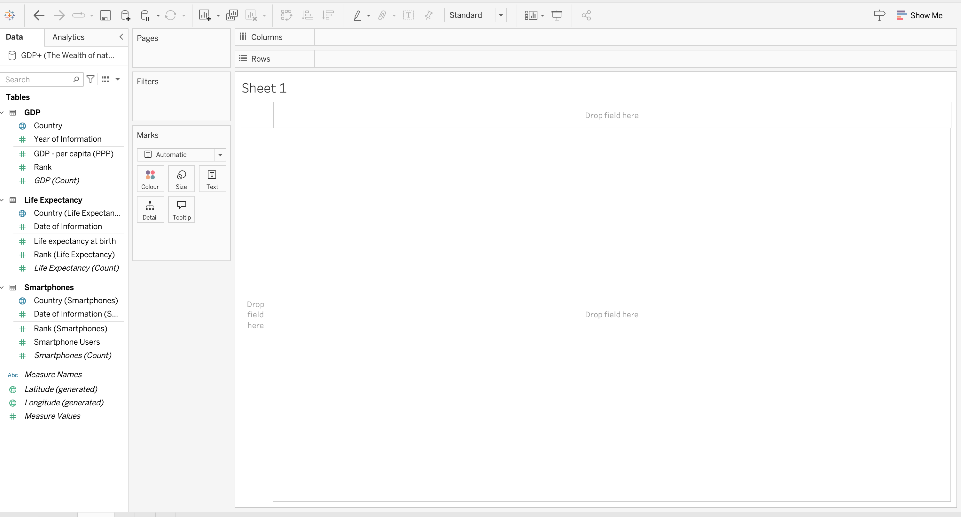

### First Chart – Bar Chart

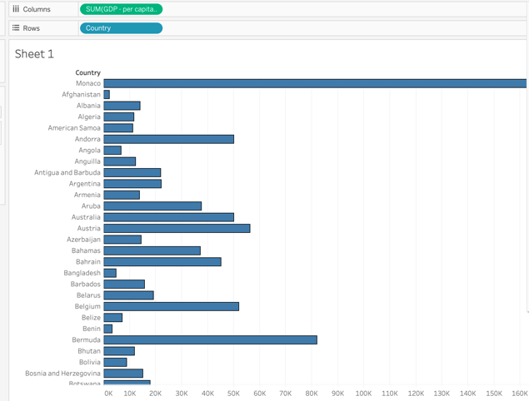c) My client has asked for at least four visuals, highlighting just the top twenty countries in rank to assist with making informed decisions as to their business going forward. I will start with a bar chart to identify the top twenty countries based on their GDP - Per Capita. From my tables I drag Country into “Rows” and GDP. -Per Capita into “Columns”. Tableau automatically applies a bar chart based on this configuration of data as it determines it as the best match.

d) I apply a filter based on rank, to exclude unwarranted data from countries outside this rank. To do this I first select “Rank” from tables. I then drag this into the filter section. I select the top option “Sum” and click next. I then from the “Range of Values” tab reduce the 228 nations field down to 20. And select Ok.

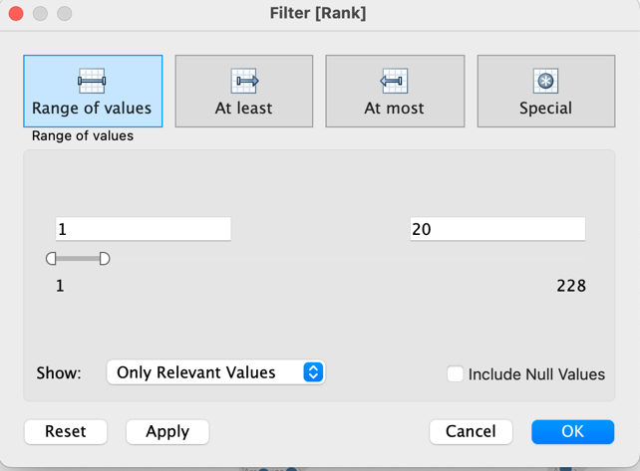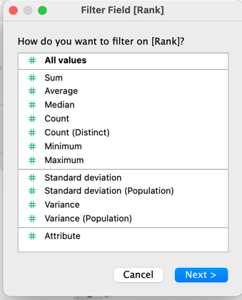

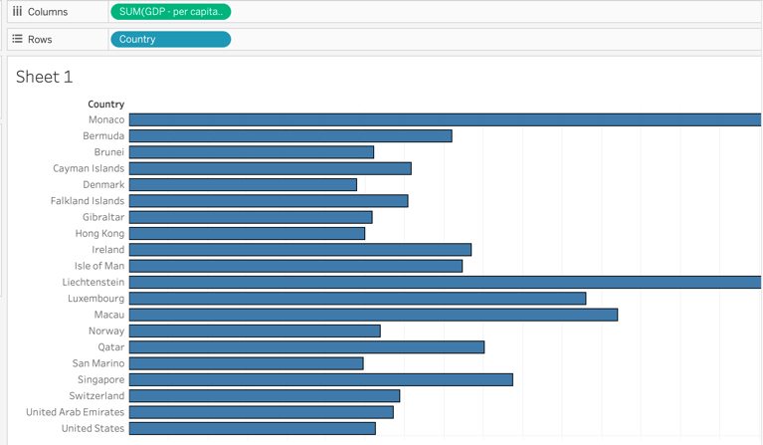 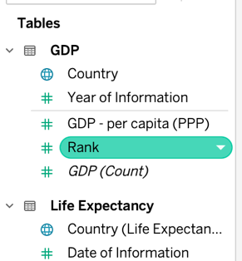

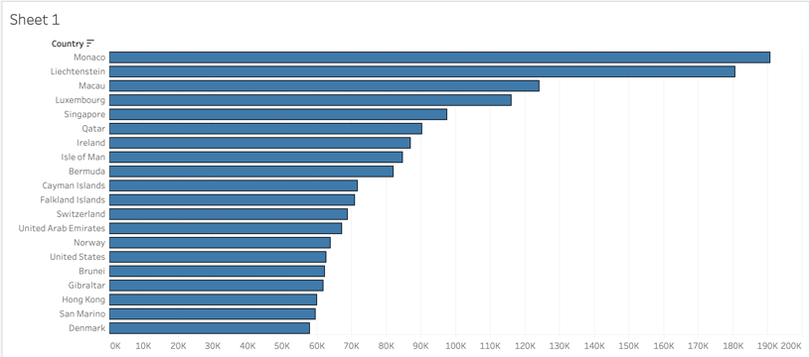e) My Bar chart on the Canvas has now reduced to include just the top twenty ranking nations. My next step is to arrange the bar chart to descend from highest GDP – per capita in these countries to better visualise the rank. To do this I select the “Country” drop down menu from the canvas header and select from the “Field” option I select ‘Sum of GDP - Per Capita”.

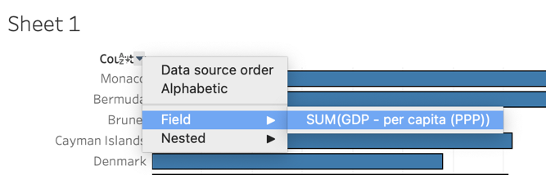

f) My client is colourblind and so my visualisations will need to cater to meet the needs of their processing disorder. Reading from the *Tableau* blog post located at - [*https://www.tableau.com/blog/examining-data-viz-rules-dont-use-red-green-together*](https://www.tableau.com/blog/examining-data-viz-rules-dont-use-red-green-together)

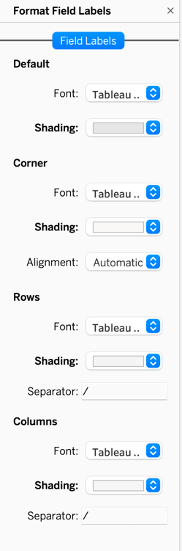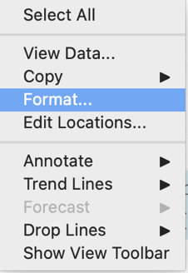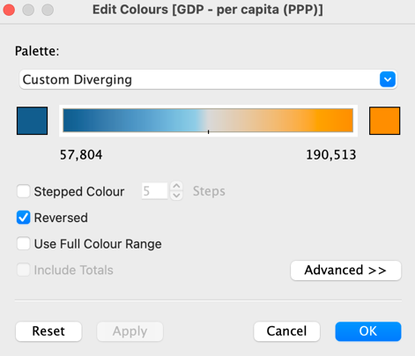It is specified that a combination of red and green within visualisations could provide a difficulty for those with colour-blindness to process. A positive visualisation palette of Blue and Orange was pointed out in the article. Hence by dragging “Sum of GDP per Capita” to the “Colour” Mark. I am presented with further options to edit the colours in my chart. I choose a blue and orange divergent combination to meet the needs of my client when viewing the data. I then right click on my axis and select “Format” to edit the colour and shading options for my axis.

g) I am left with the task of renaming my chart from the Canvas by double clicking. I rename it “Sum of GDP across top 20 ranking countries”, I will centre the text and select a font and italics. I will also rename my worksheet at the bottom of the page “Sum_Of_GDP”. My first chart is a striking and engaging bar chart that uses colour effectively and responsibly as per my client’s request. I believe it is informative and focuses attention on providing an answer to my chart title.

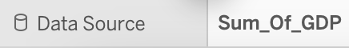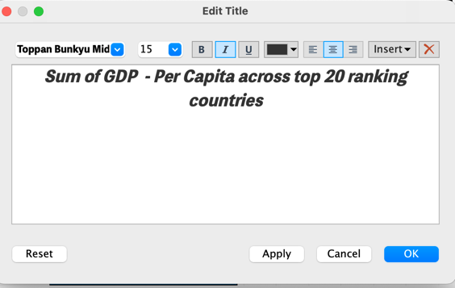

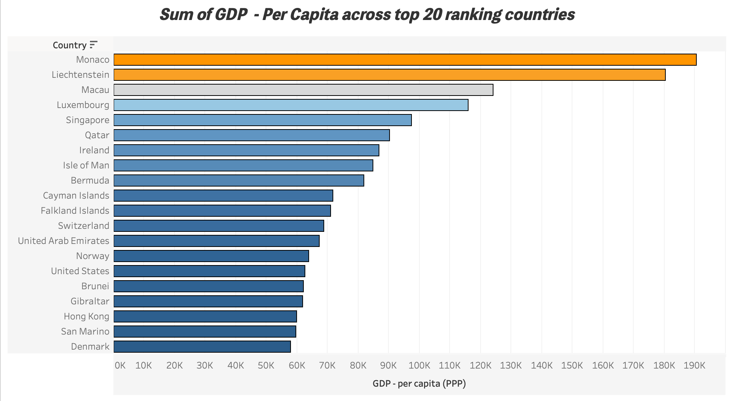

### Second Chart – Tree Map

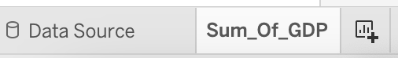a) To separate my work for the time being and begin work on my second chart, I will select the “New Worksheet” option located at the bottom of the original Tableau sheet. From this new sheet I can start putting together my next chart type.

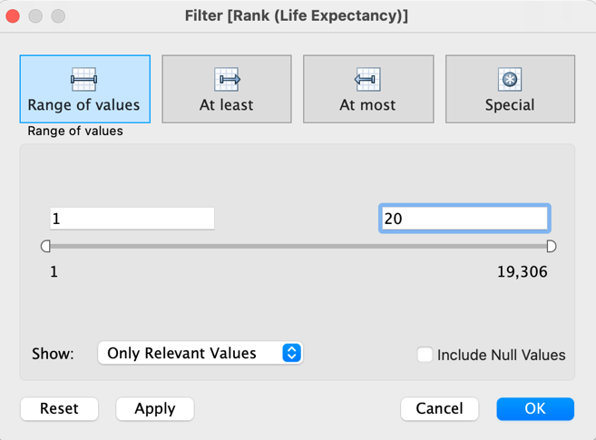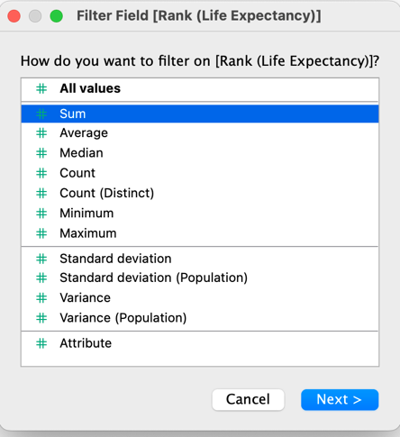 b) This time I will be creating a tree map to display the top 20 countries according to Life Expectancy. I will follow the same process as before and drag Rank (Life Expectancy) into the Filters area and select “Sum`’ and Ok. Then from the next menu I amend range of values from 1 to 20.

c) I then drag my Dimension Country Life Expectancy) to the columns field. And my Measure Life Expectancy at Birth to the rows field.

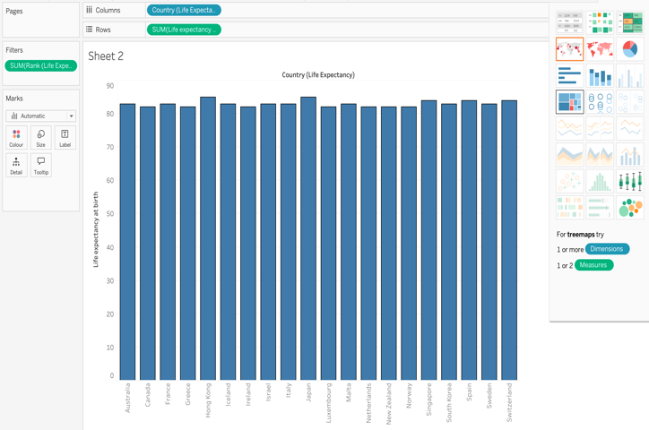d) This creates a bar chart by default on Tableau, to transform this into a tree map, I will select the Tree map icon from the “Show Me” drop down menu.

e) My data has now been reworked into a tree map, my parameters for colour have been kept from the previous chart which is in keeping with the colour blind accessibility request from my client and provides a continuity between the separate charts.

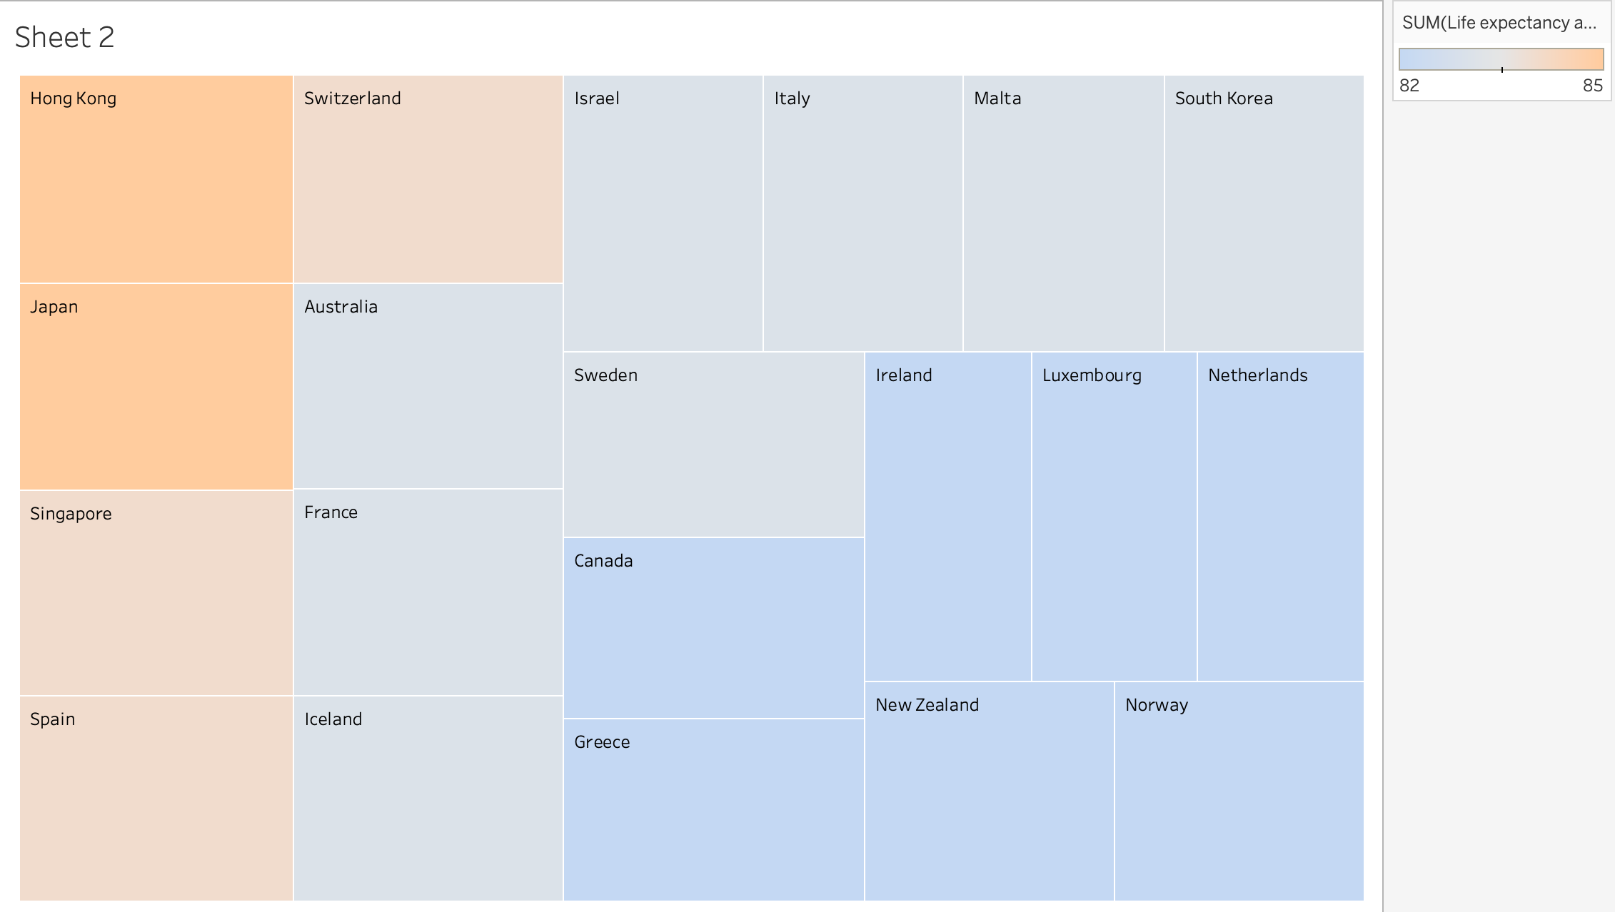

f) To improve the visual, I select the drop down from the Legend at the top left, and select “Edit Title”. I then rename the legend “Life Expectancy in Years”

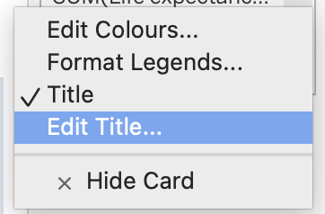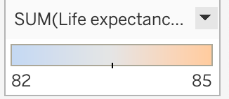

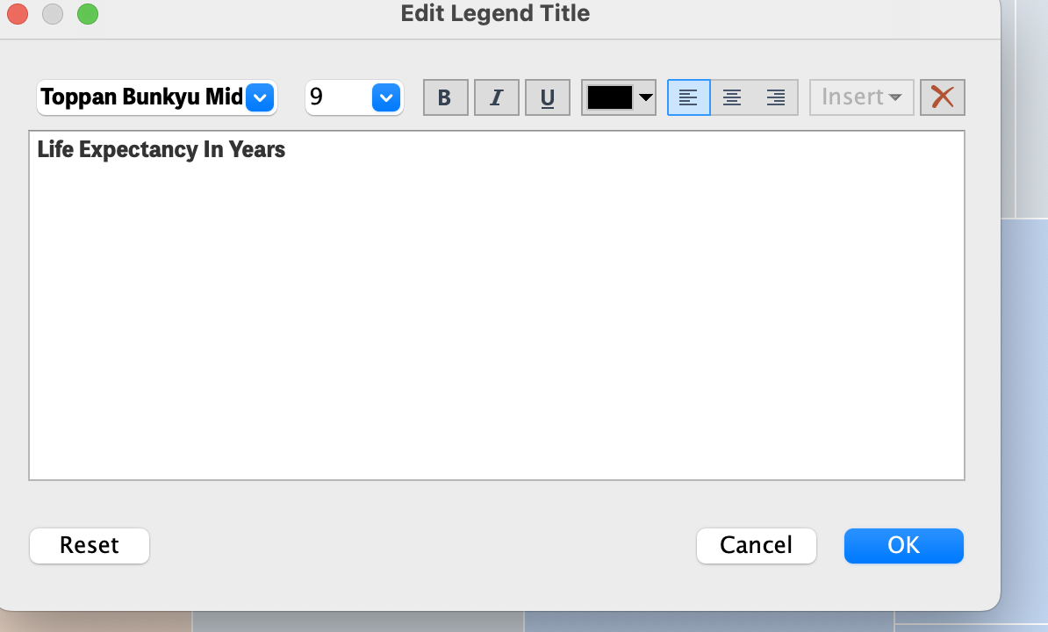

g) My second chart is now complete with a simple and user friendly design, I trust that my client will be able to navigate the interactive chart when hovering over the countries to acknowledge each nations life expectancy, but at a glance they can also determine from the legend and the positioning of the data in the tree map, which nations top the chart and which sit at the bottom.

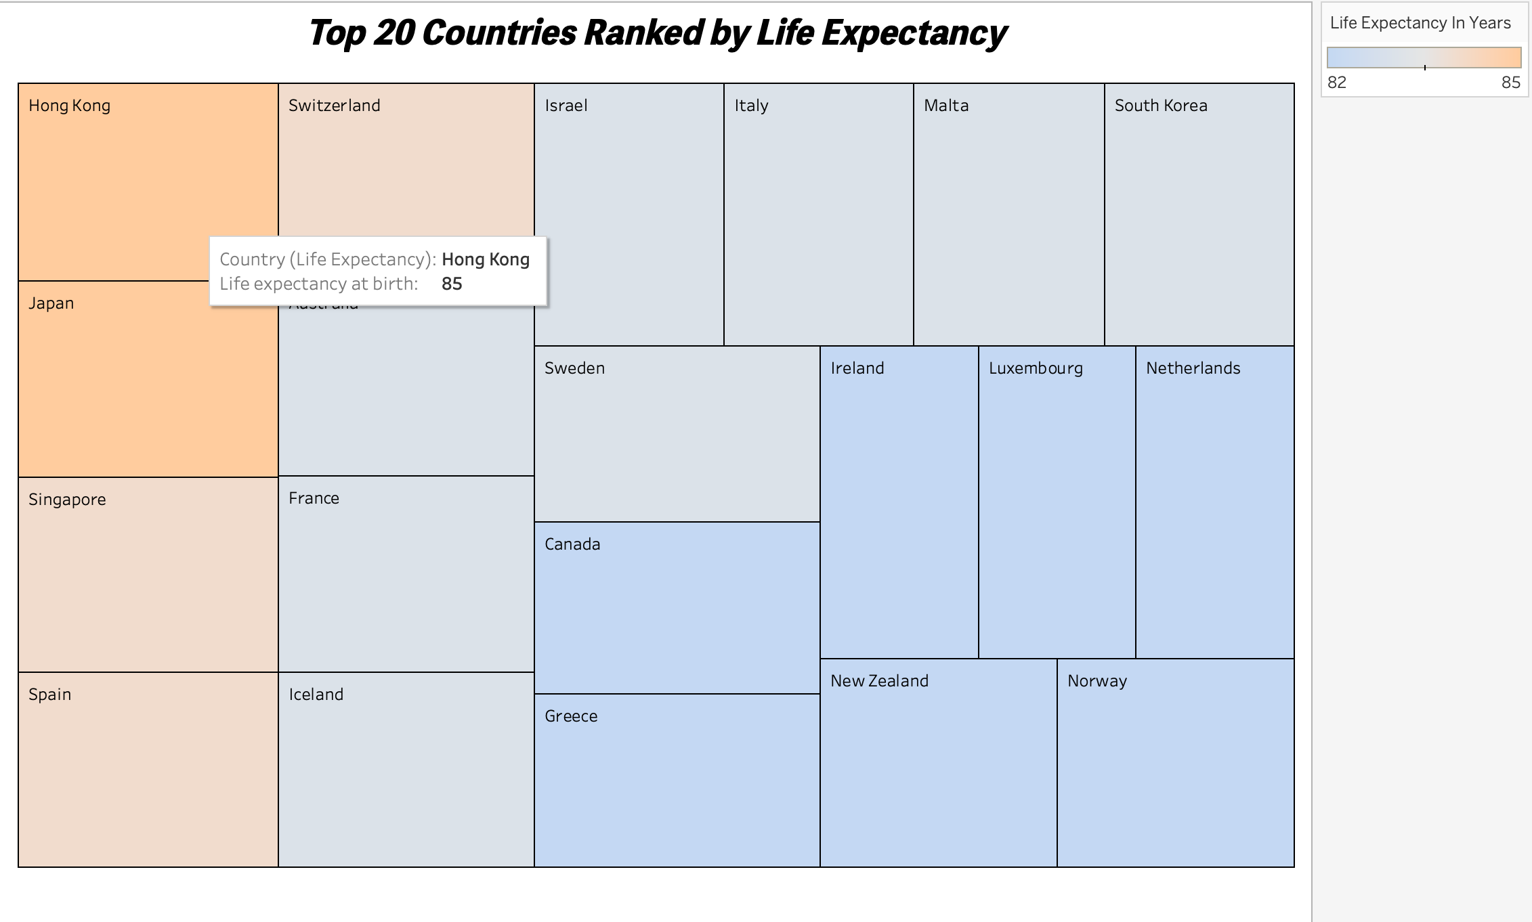

### Third Chart – Box And Whisker Plot

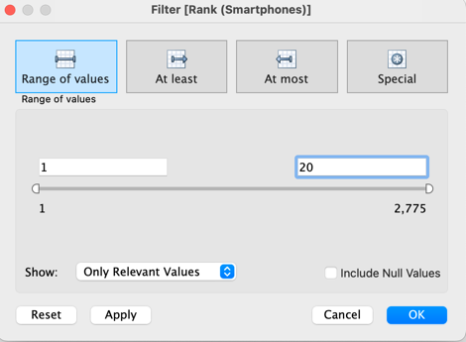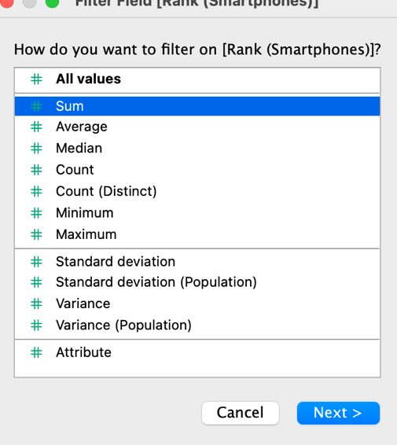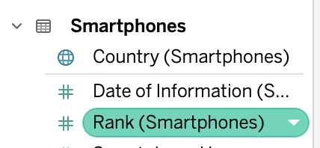a) For my third chart I will provide my client with a box and whisker plot to highlight the top 20 ranking nations according to the number of Smartphone users. To get started I will once again create a filter to only include the top 20 countries from the Rank measure.

b) Next I will drag dimension Country (Smartphones) into columns field, and Measure Smartphone Users into the rows field. This will create the chart below by default on Tableau.

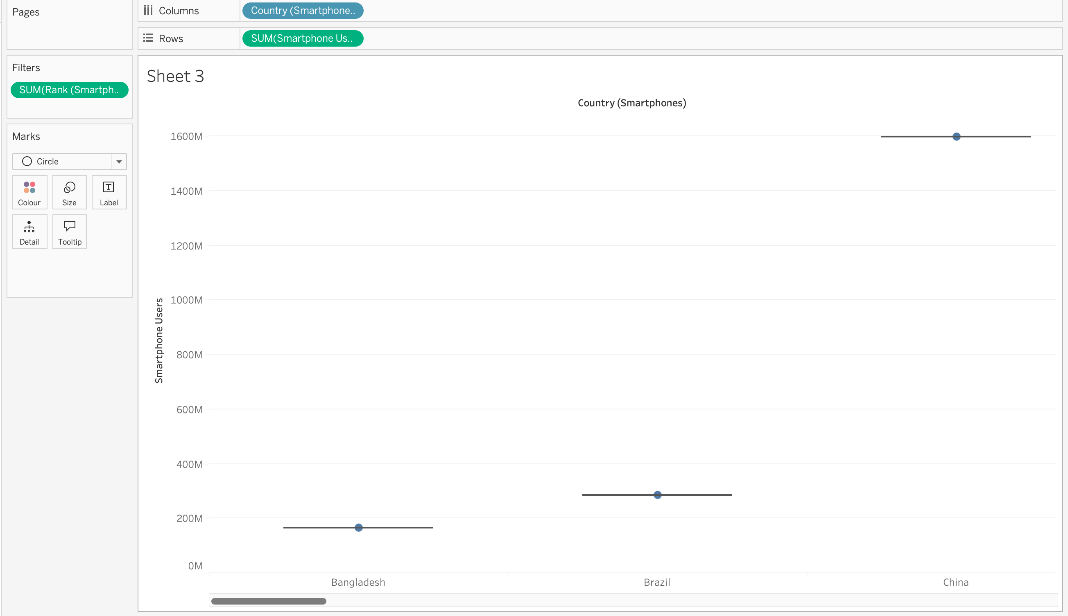

c) To amend this data into a traditional Box and Whisker plot I will select the box and whisker plot icon from the “Show Me” drop down menu.

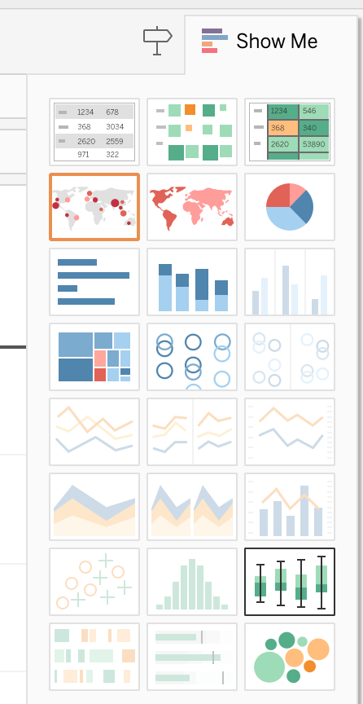

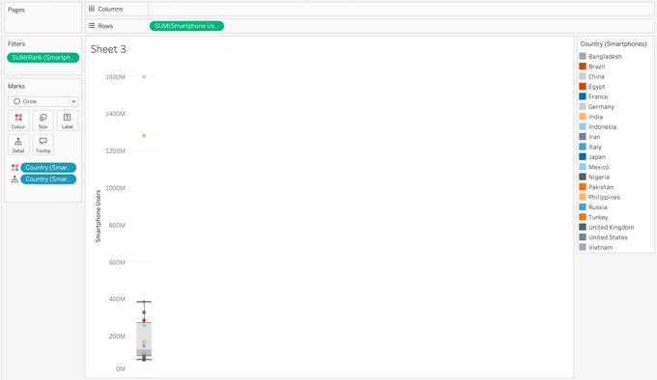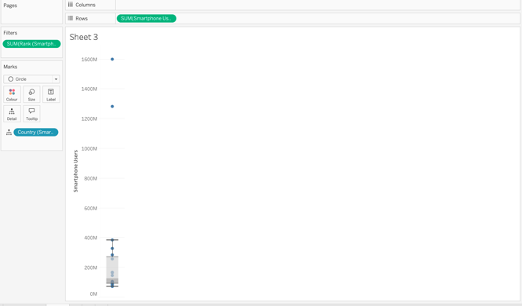d) This provides us with the below Box and Whisker plot. To begin improving the visual and highlighting the outliers in this chart I will drag the Country dimension into the colour marks. This provides us with a legend on the top left to help identify the countries.

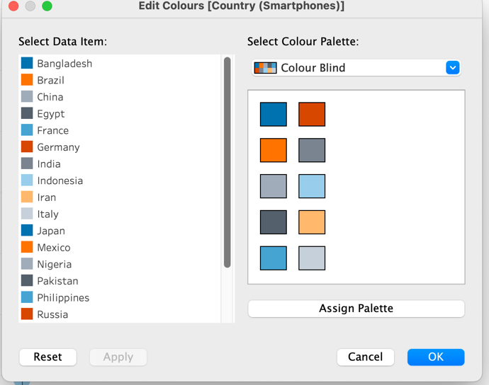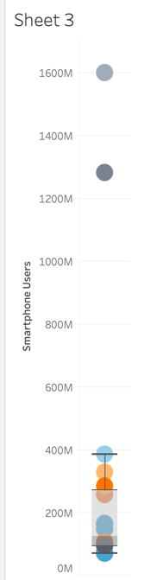e) Next to increase the size of my chart, I select the size icon from the marks and use the slider to increase the size of my chart features. Secondly I check my colour mark is appointed to Colour blind.

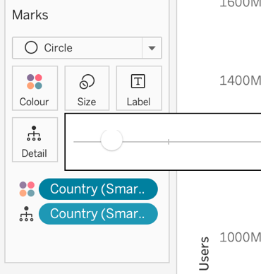

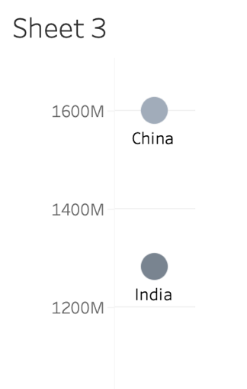f) To improve the ease of reading the chart I drag the country (smartphones) dimension from table to the Label mark, this presents the country name beneath my two outliers in the chart.

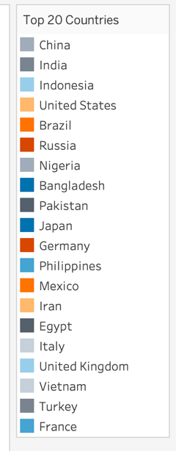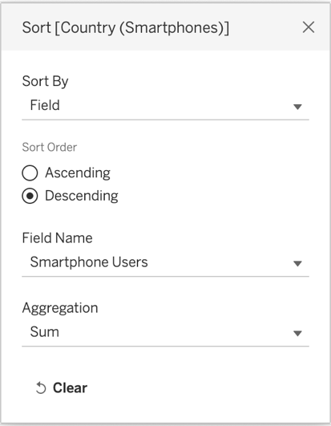g) Next I rename my Legend as well as choosing to sort it by Descending sum of users. I select sort from the legend drop down menu, amend to field and select descending.

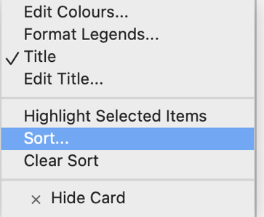h) I right click my Y axis on the canvas and select edit axis, on the following page I rename my axis “Smartphone Users by Millions”. I then right click my Y axis again and select Add reference line, this indicates the average number of smartphone users in my top 20 countries via the text “Average” on the chart.

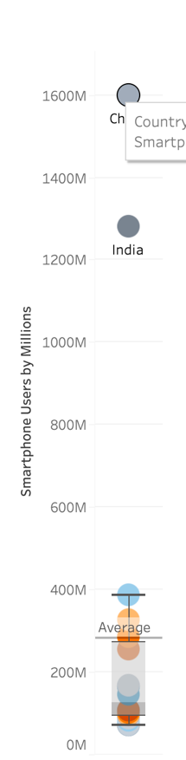

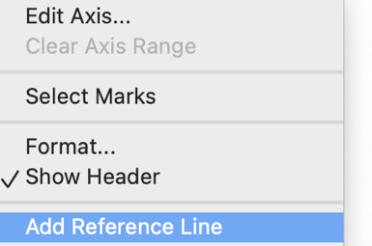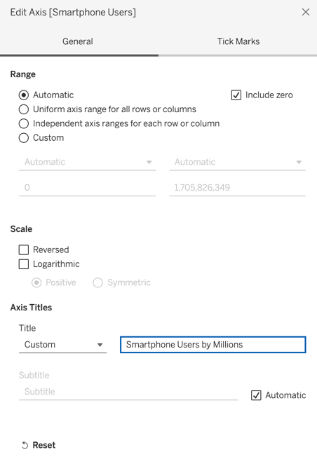

i) My Box and Whisker plot chart is complete, it has the built in benefit of highlighting the statistical benefits of the median when interacted with and serves as a great portrait of the more similar groups of nations and the contrast in larger scaled figures for China and India in this case.

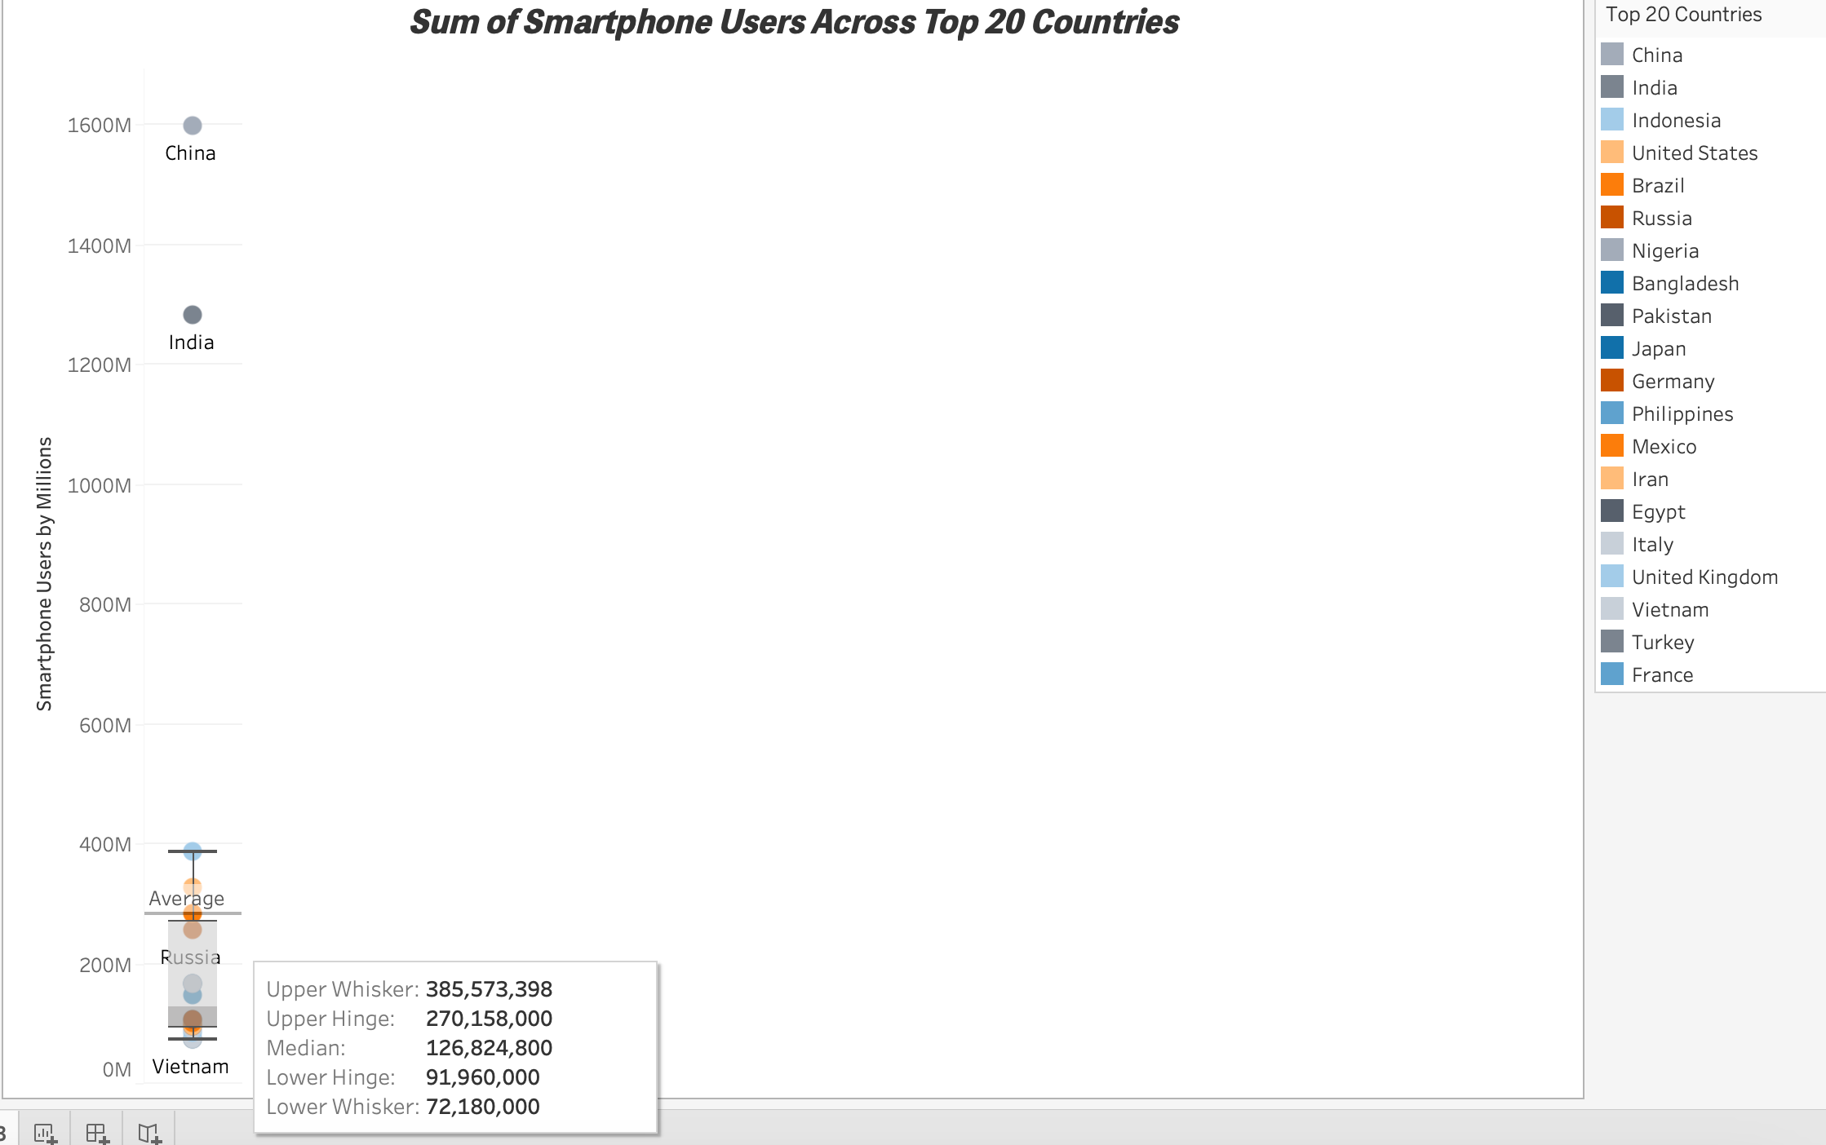

### Fourth Chart – Filled Map

For my final chart I want to provide my client with a Filled Map chart, this chart will be more ambitious than the previous three, but it will combine elements of each of them in one informative visual. The visual will provide an insight into the top 20 smartphone users by nation, their GDP – per capita and their life expectancy from birth. This should serve my client as an indicator as to the wealthier of their top 20 smartphone using nations, and which nations may be a focus for future decisions based on the impact of their life expectancy.

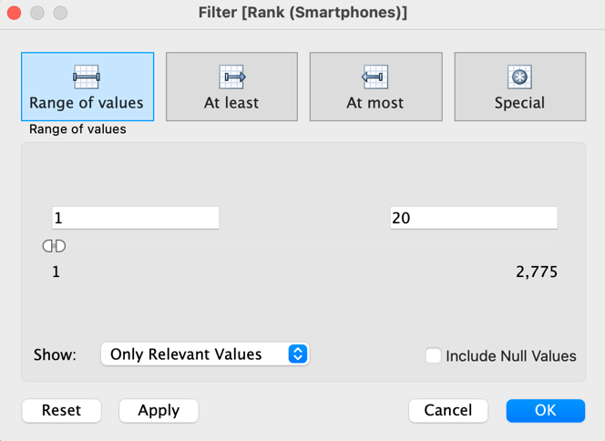a) Firstly I will drag my Smartphone users by rank into the filter field. As usual I will reduce my range of values between 1 and 20.

b) Next from my GDP – Country table I will double click this field which will instantly open up a map with circled bubbles for each of the top 20 countries for smartphone users.

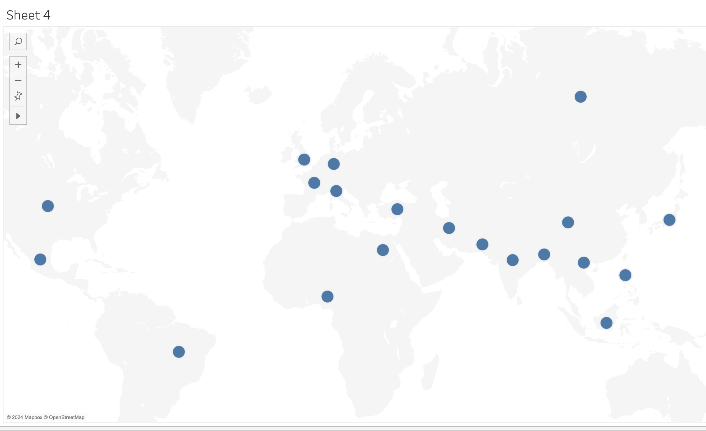

c) To begin adding important context to the map from the other tables, I will drag the measure for life expectancy at birth into the colour Mark.

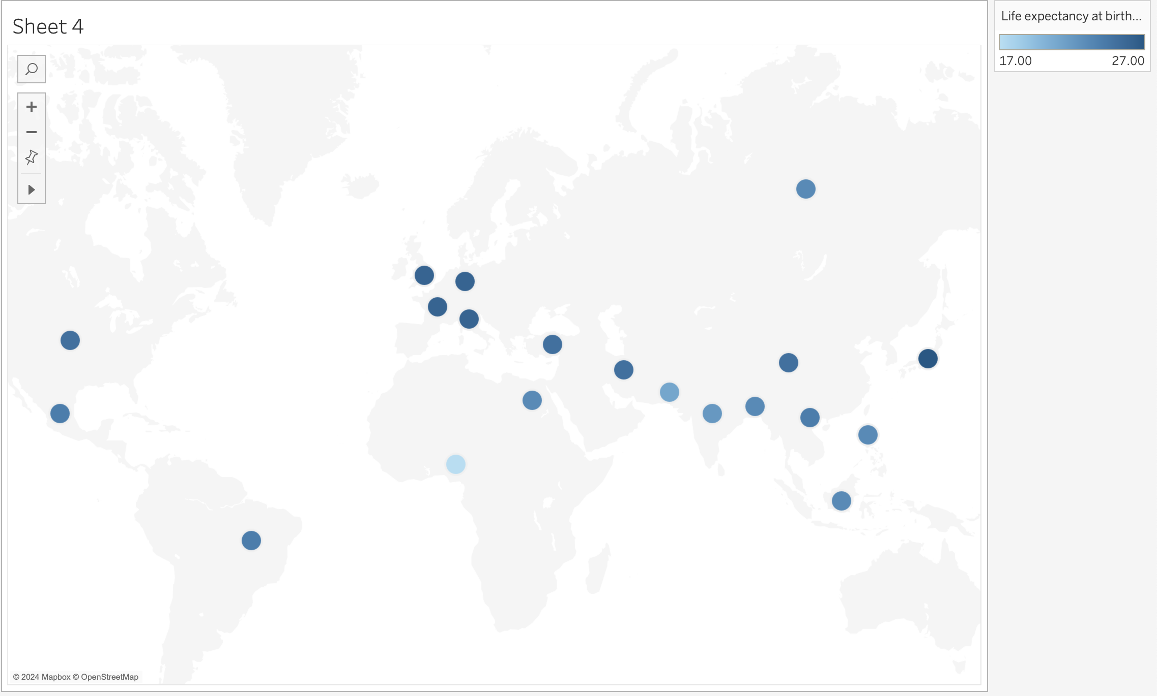

d) To better display the contrast and in keep with the colour blind assignment requirement, I will edit the colours to diverge between orange and blue.

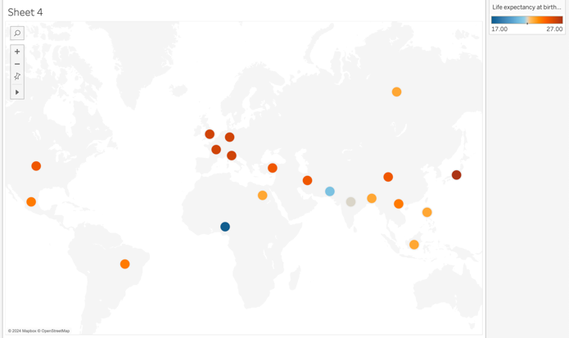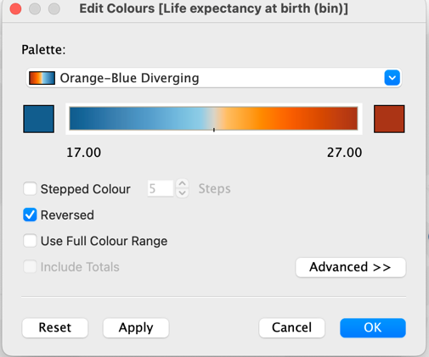

e) To display the number of smartphone users against their location on the map. I drag Smartphone users from measures into the label mark.

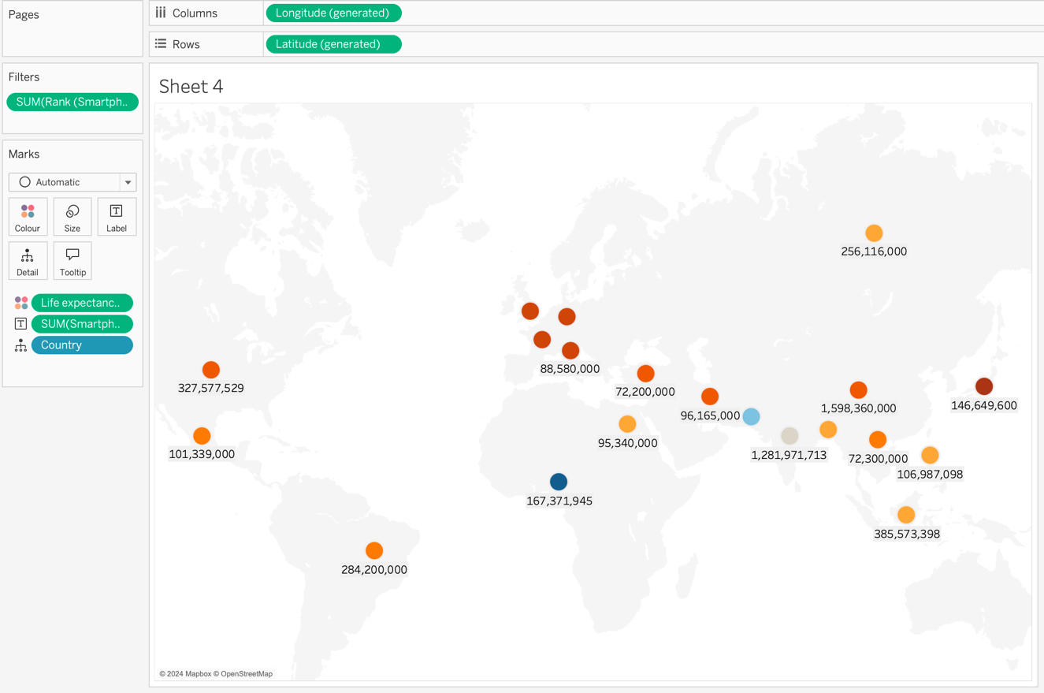

f) To display the size of GDP - per capita per nation, I drag this measure into the size mark.

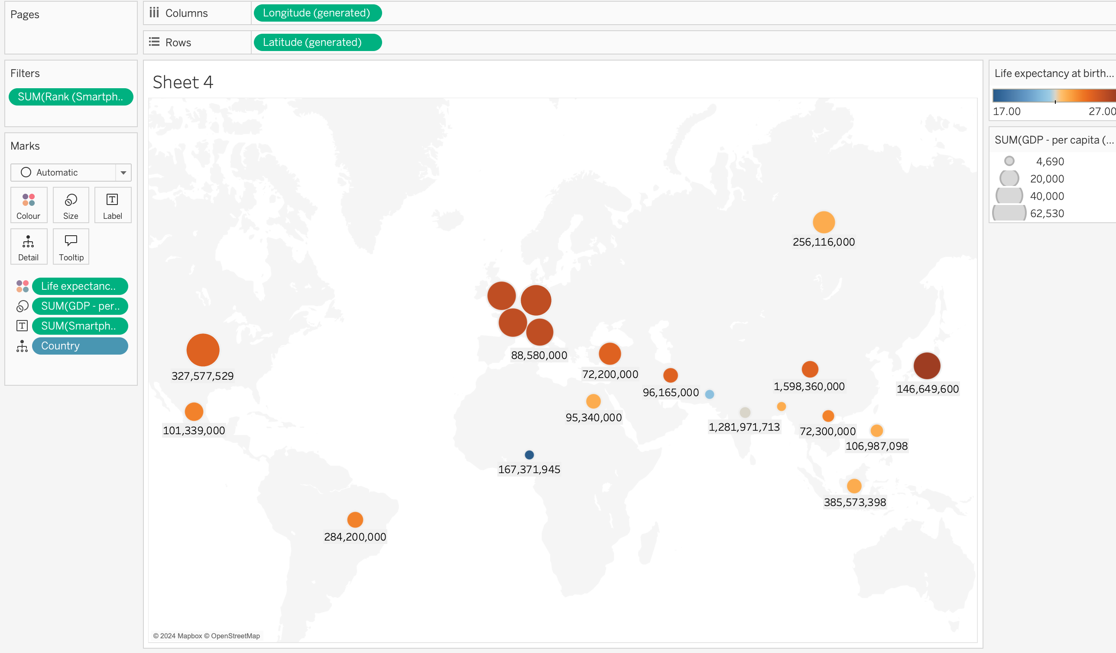

g) Now I turn my attention to the background of the map. To amend this blank canvas to something more fitting, I use the Map drop down at the top of the application ribbon and select Background Maps and Satellite. This provides a rich background for the canvas to pop against my highlighted data.

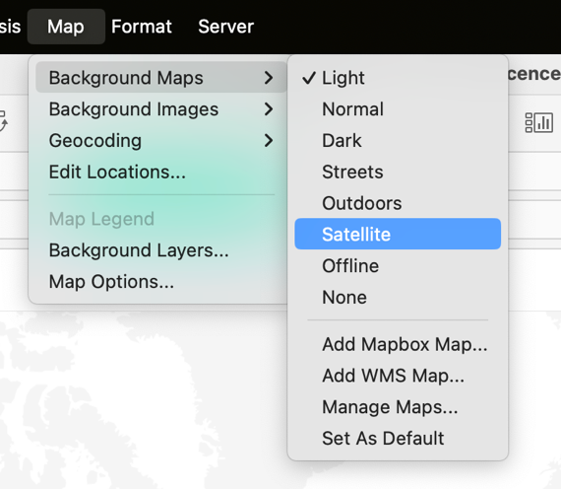

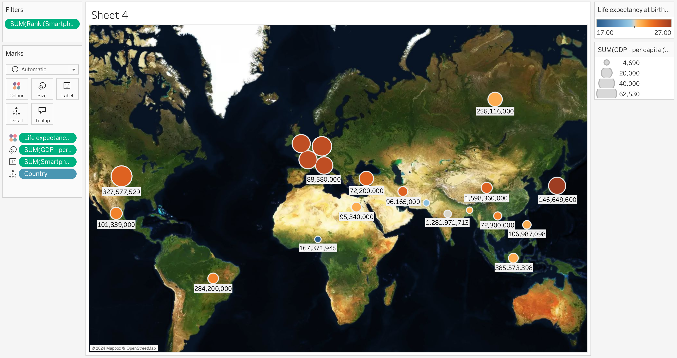

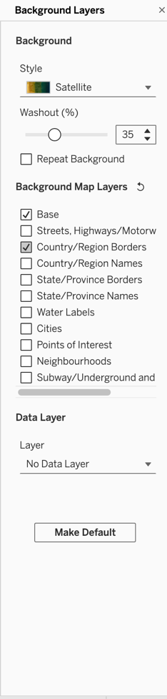h) Now to make additional creative amendments and improve the data’s visual context against the background, I return to the map ribbon and from the drop down this time select Background Layers. On the left side menu I increase washout effect to 35% and tick Country region borders.

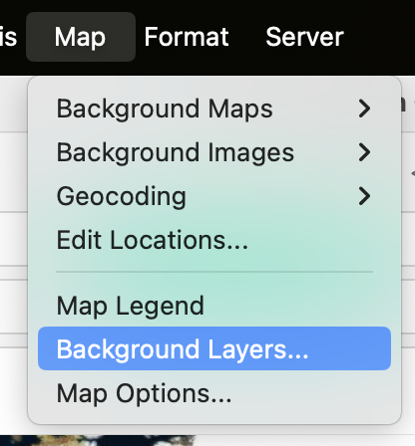

g) Next I add further context to the map I drag Country Smartphone dimension into the Labels mark, which provides text to assist with the nations location on the map.

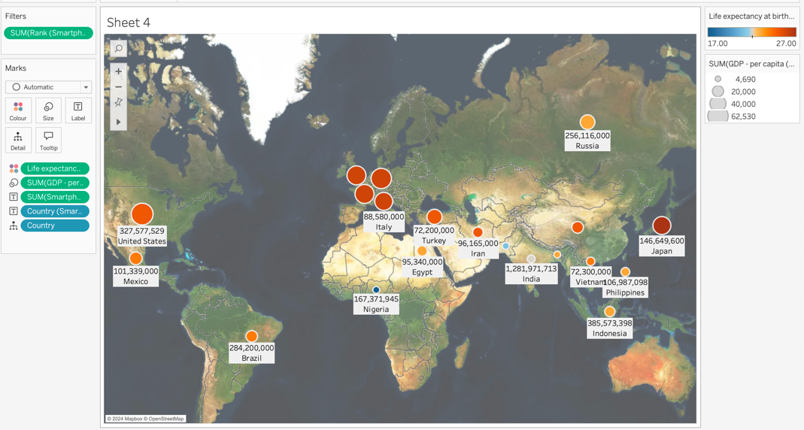

h) I finally edit the Sheet title and legends. My life expectancy is measured via colour lowest blue to highest orange. My GDP per capita legend is measured via size of the bubble. My final Chart visual is an interactive display across the three tables that were originally imported, and fittingly visualised as a filled map giving that their common link between three tables has been “Country”.

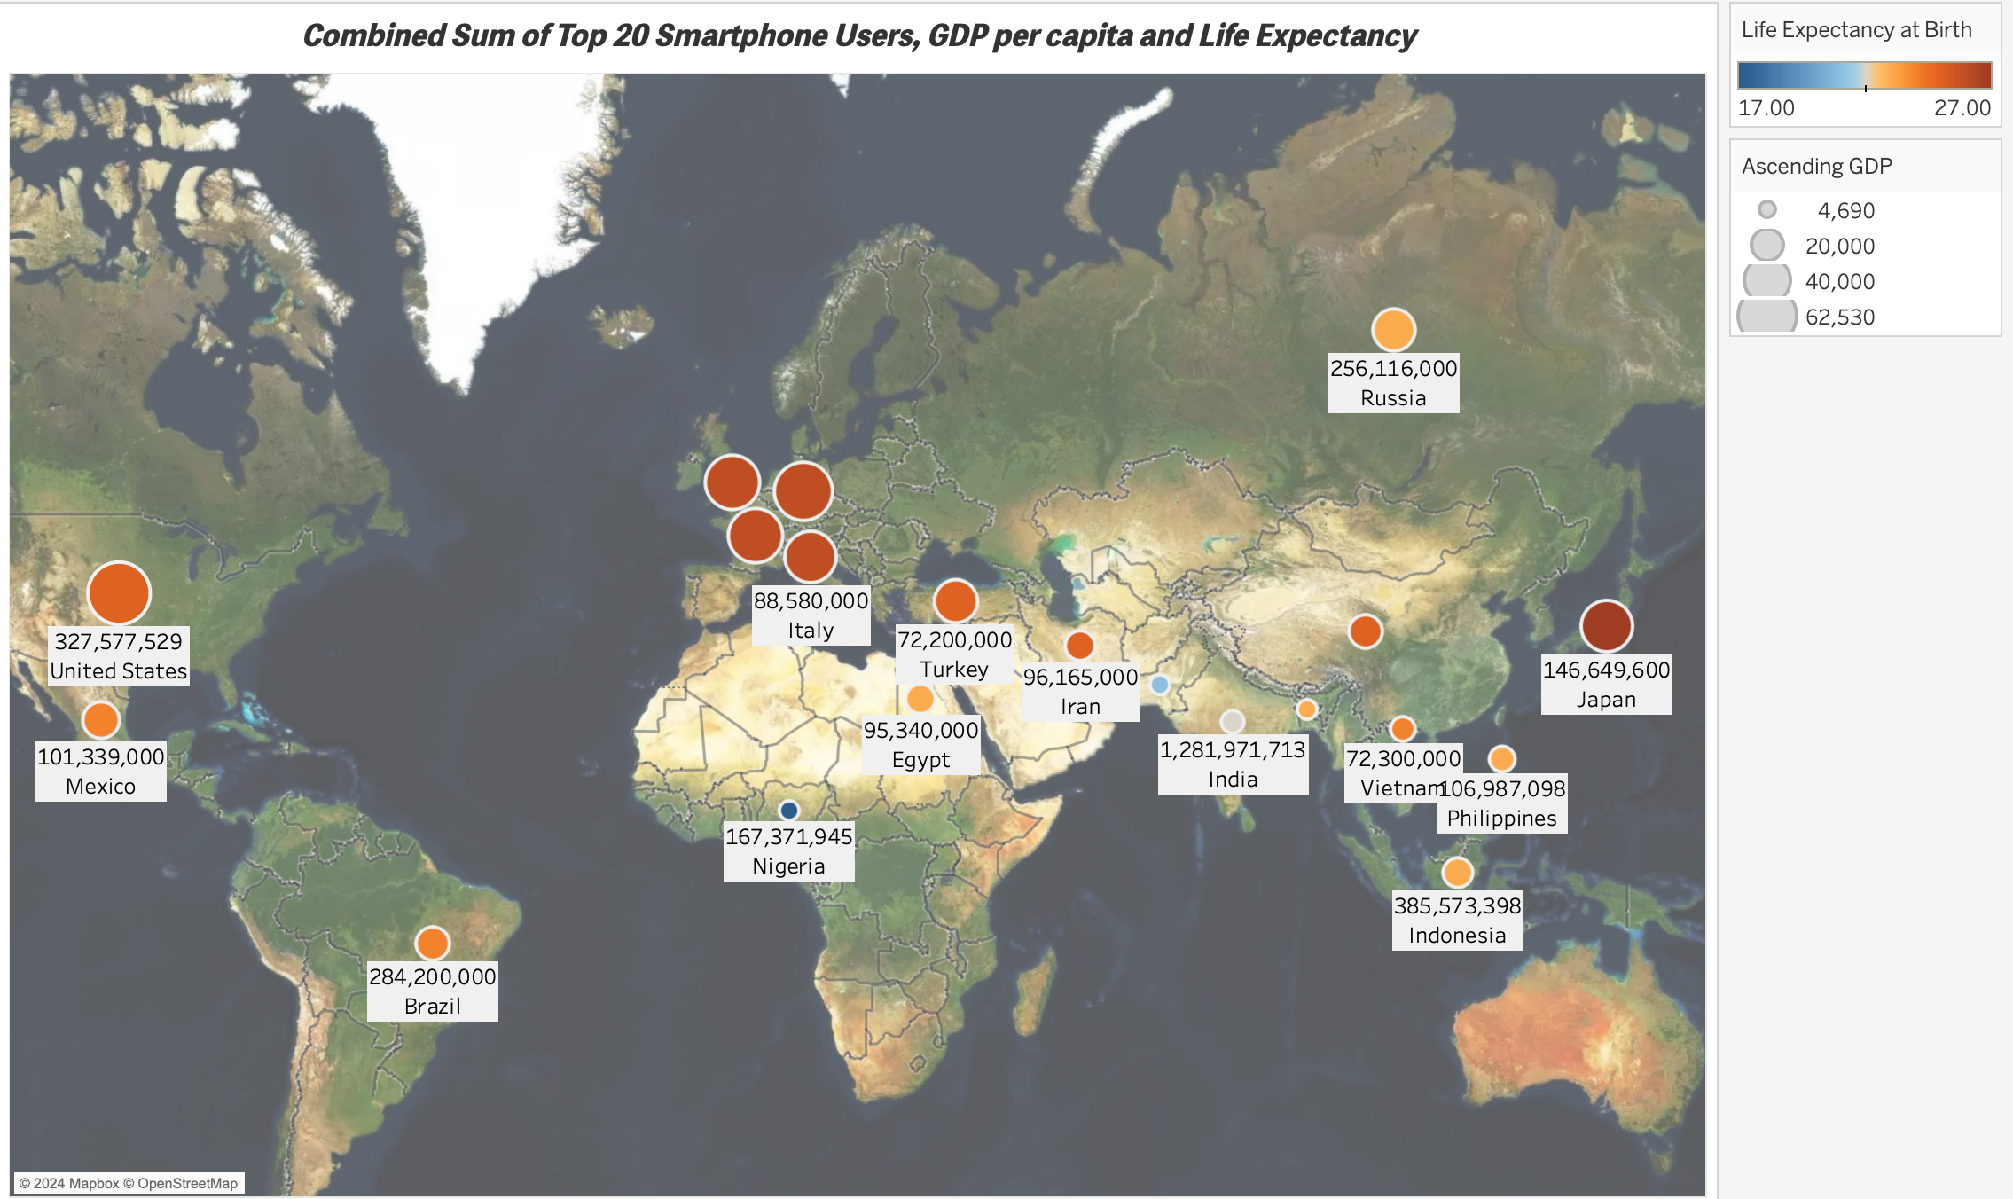

# Build A Dashboard

Now that my 4 charts have been created, my next task is to create a dashboard. Before that I will give all my sheets a name, and then select the icon next to new sheet, new dashboard.



a) My first task is to drag my named sheets from the left hand side of the dashboard into the blank canvas.

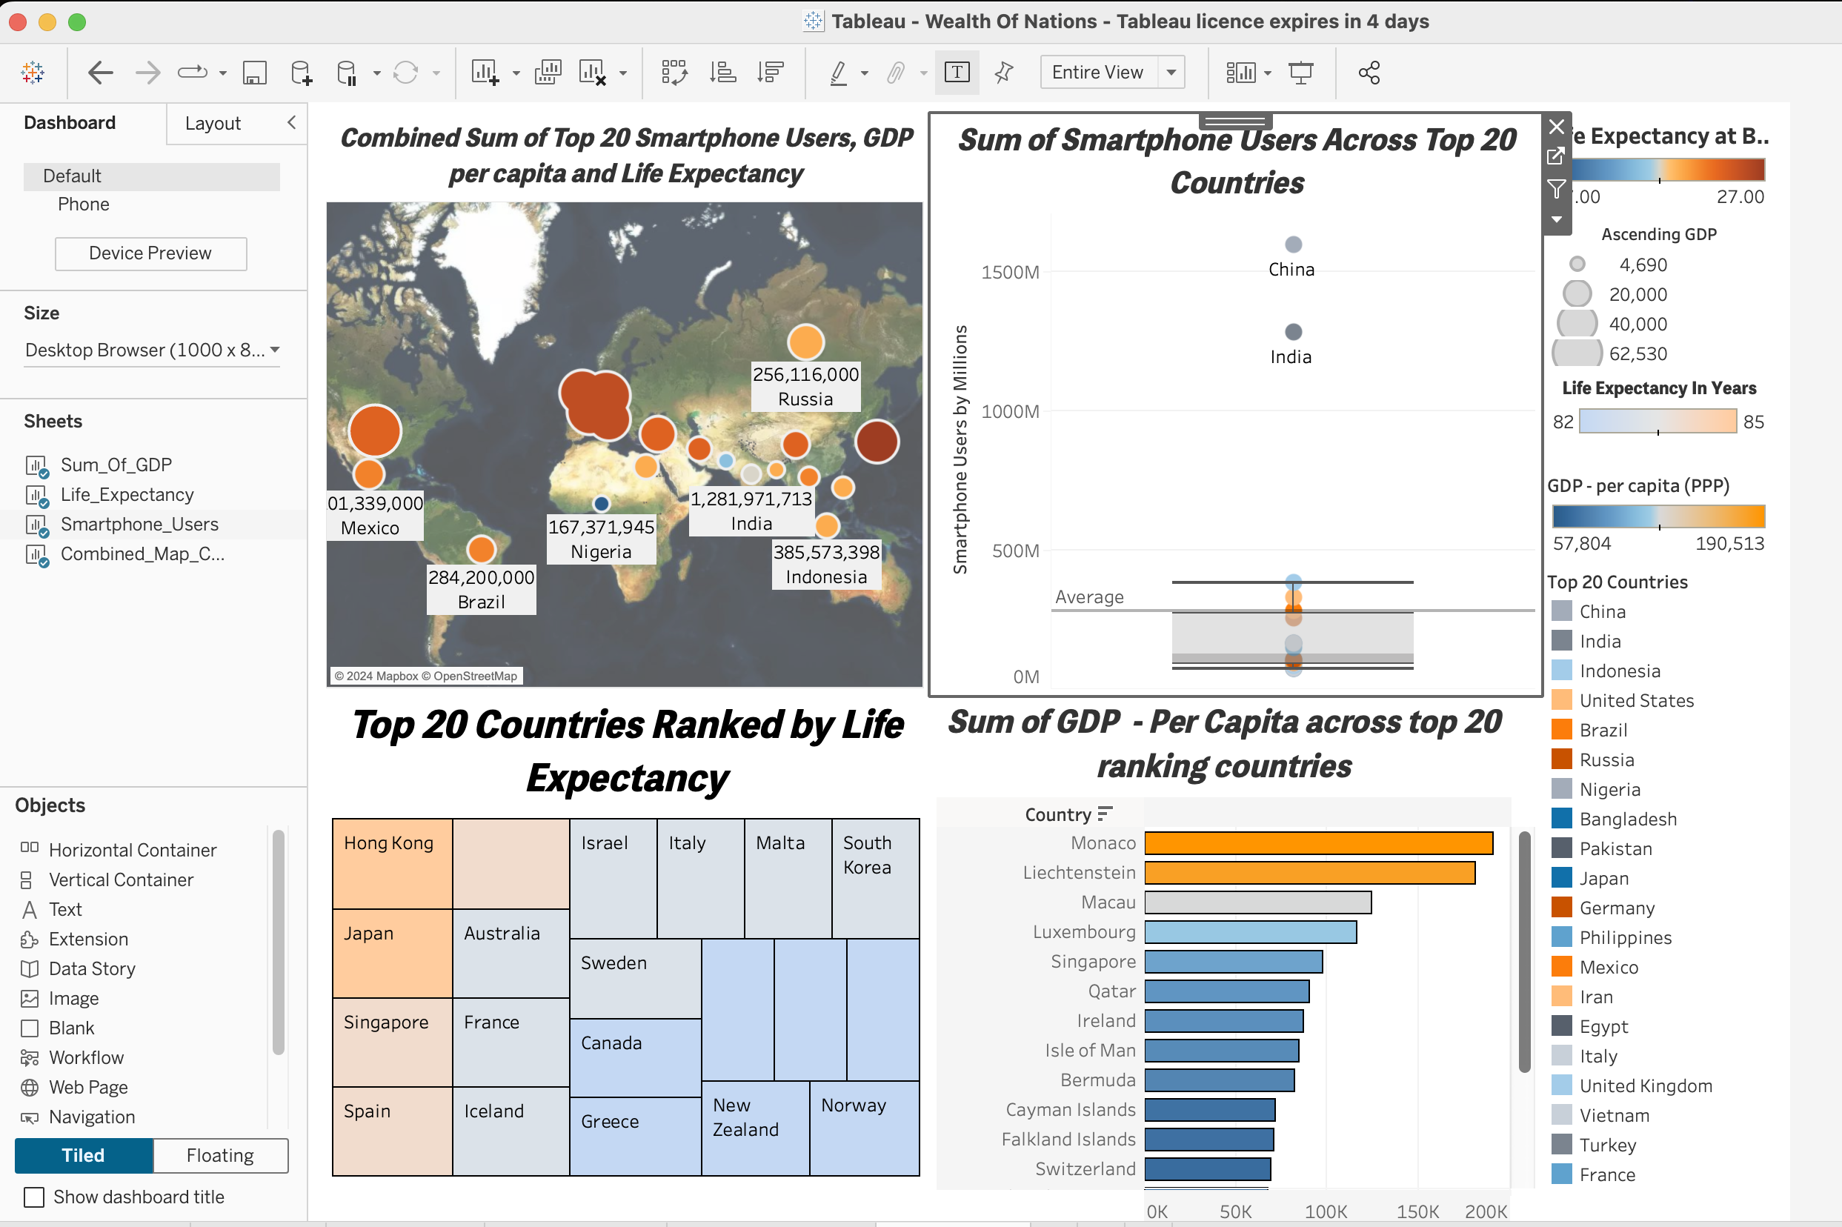

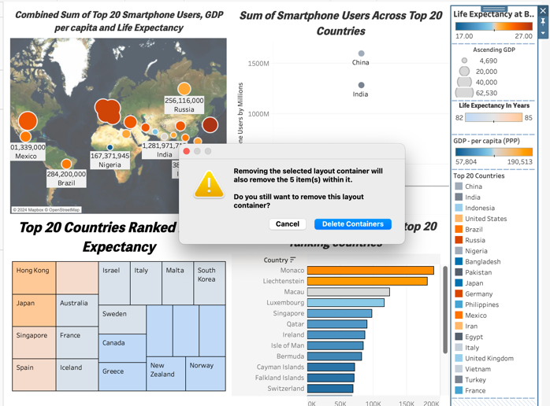b) To increase room for my charts, I will select the right hand side column storing my legends and delete the containers from my dashboard.

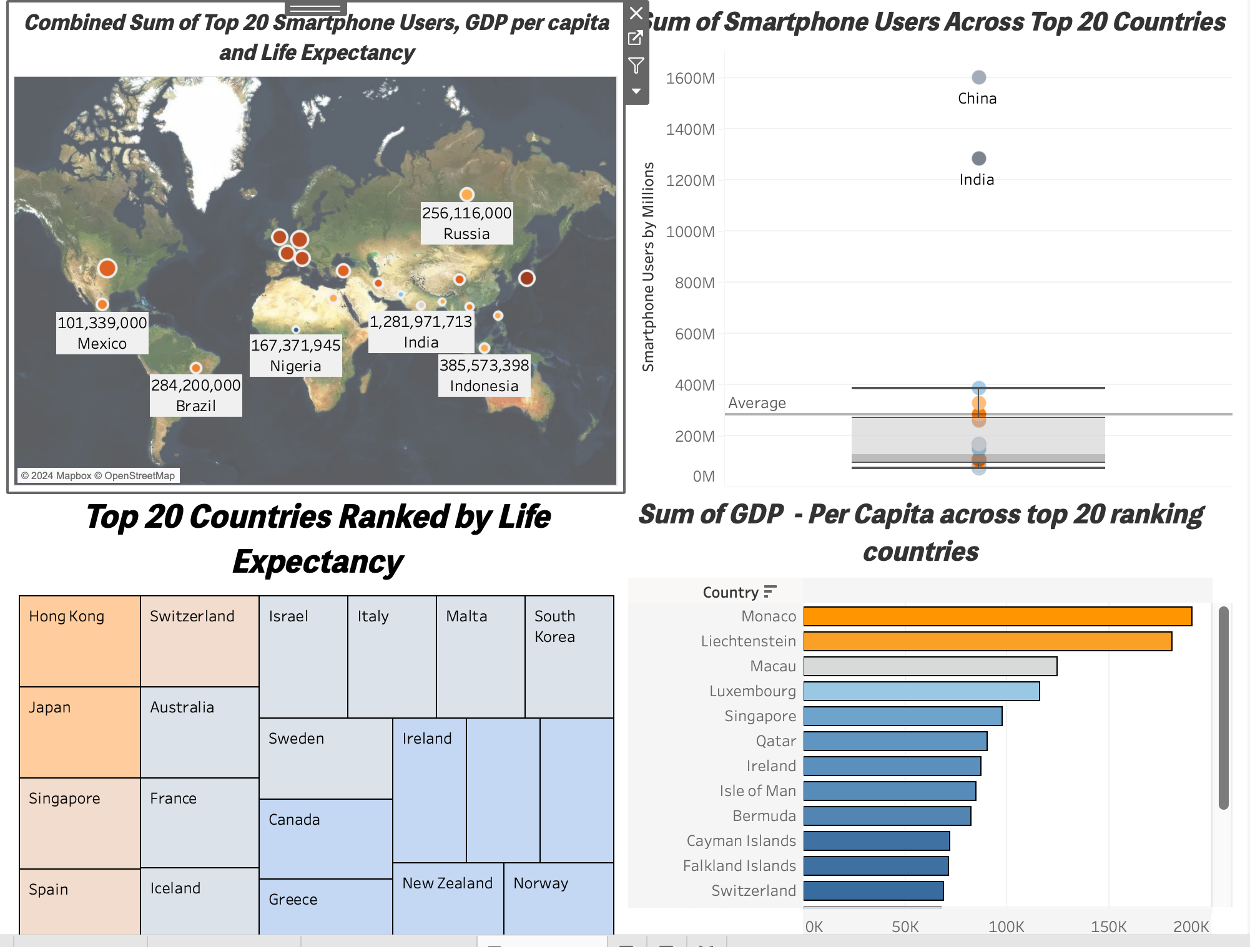

c) I will now name my Dashboard, to do so I must first select “Show Dashboard Title” from the bottom left tick box.

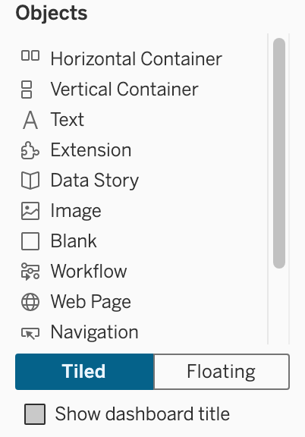

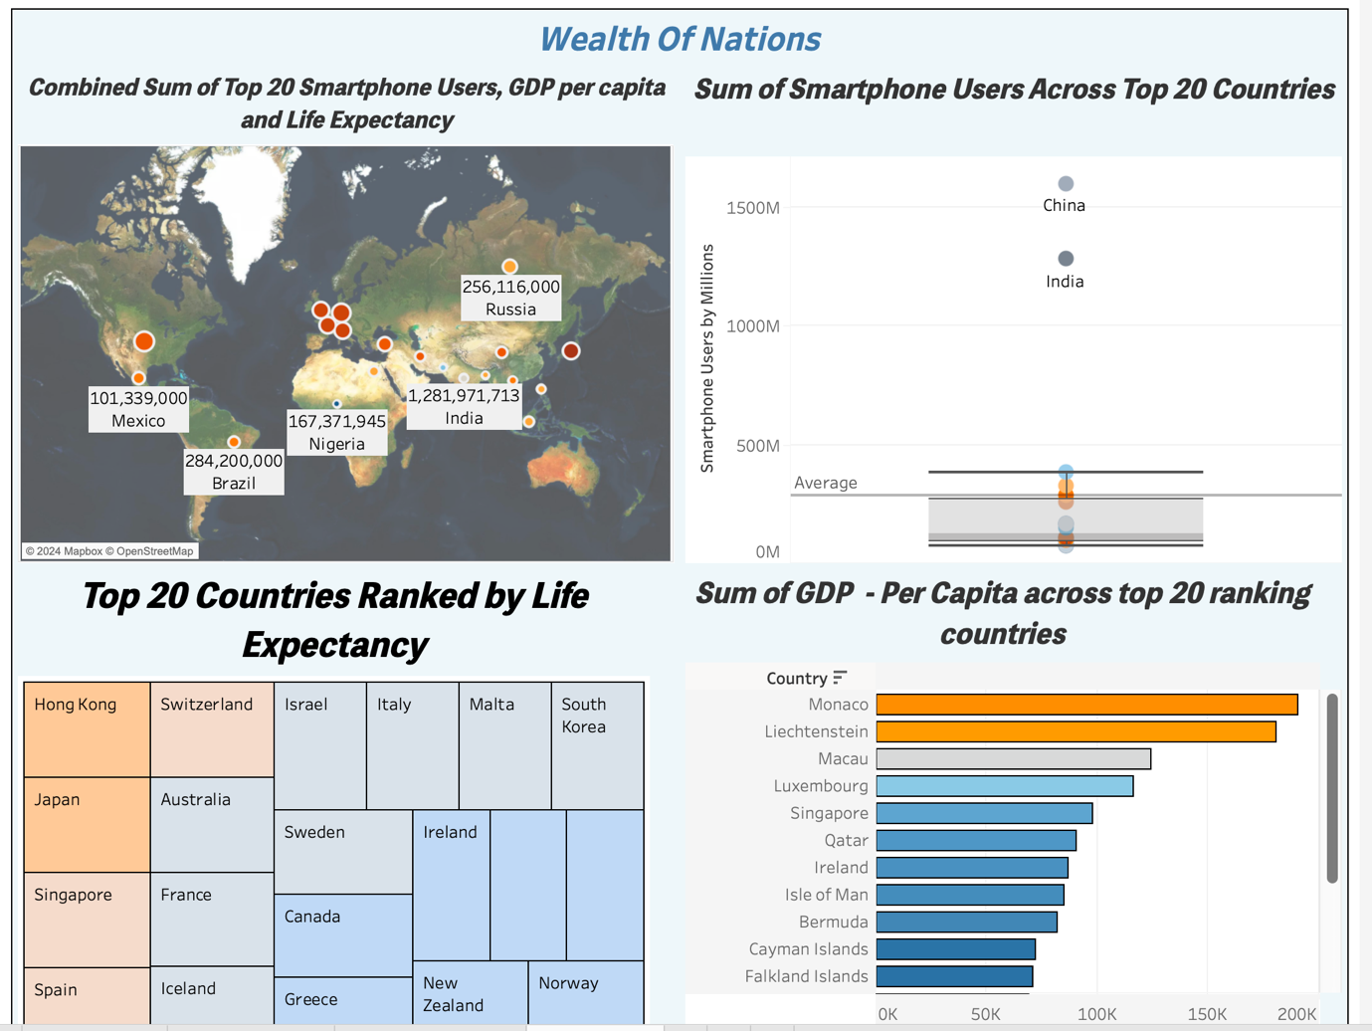d) I then rename the dashboard by double clicking at the title at the top of the page. I rename the dashboard “Wealth Of Nations” I centre the text, colour it and put it into Italics and bold. My dashboard is now complete. It will be uploaded to Tableau for my client to the Tableau Server.

# Reflection

In reflection of my assignment, I would firstly say that I found it at times quite enjoyable and rewarding to apply my learnt knowledge from the Excel and Tableau workshops, each completion of a task or step in the process of completing the assignment felt quite reassuring that I have the capabilities to work professionally with data as an analyst.

I did find areas of the assignment quite challenging and even overwhelming in part due to my interpretation of the instructions provided and secondly when I then attempted to work out a way of meeting a requirement which at times took me into areas we had not covered in detail in the workshops.

An example of a challenge which proved too difficult for me to solve would be when I was nearing the end of the assignment and building my dashboard. Despite the instructions not specifying for converting the sheets within the dashboard to be set as filters, I felt it would be a realistic expectation of an actual client to want to interact with the dashboard. When I did set any of my sheets as filters, the results most often would not pair up and with the other sheets and would blank out the separate sheets in the dashboard to provide no information, as per below image.

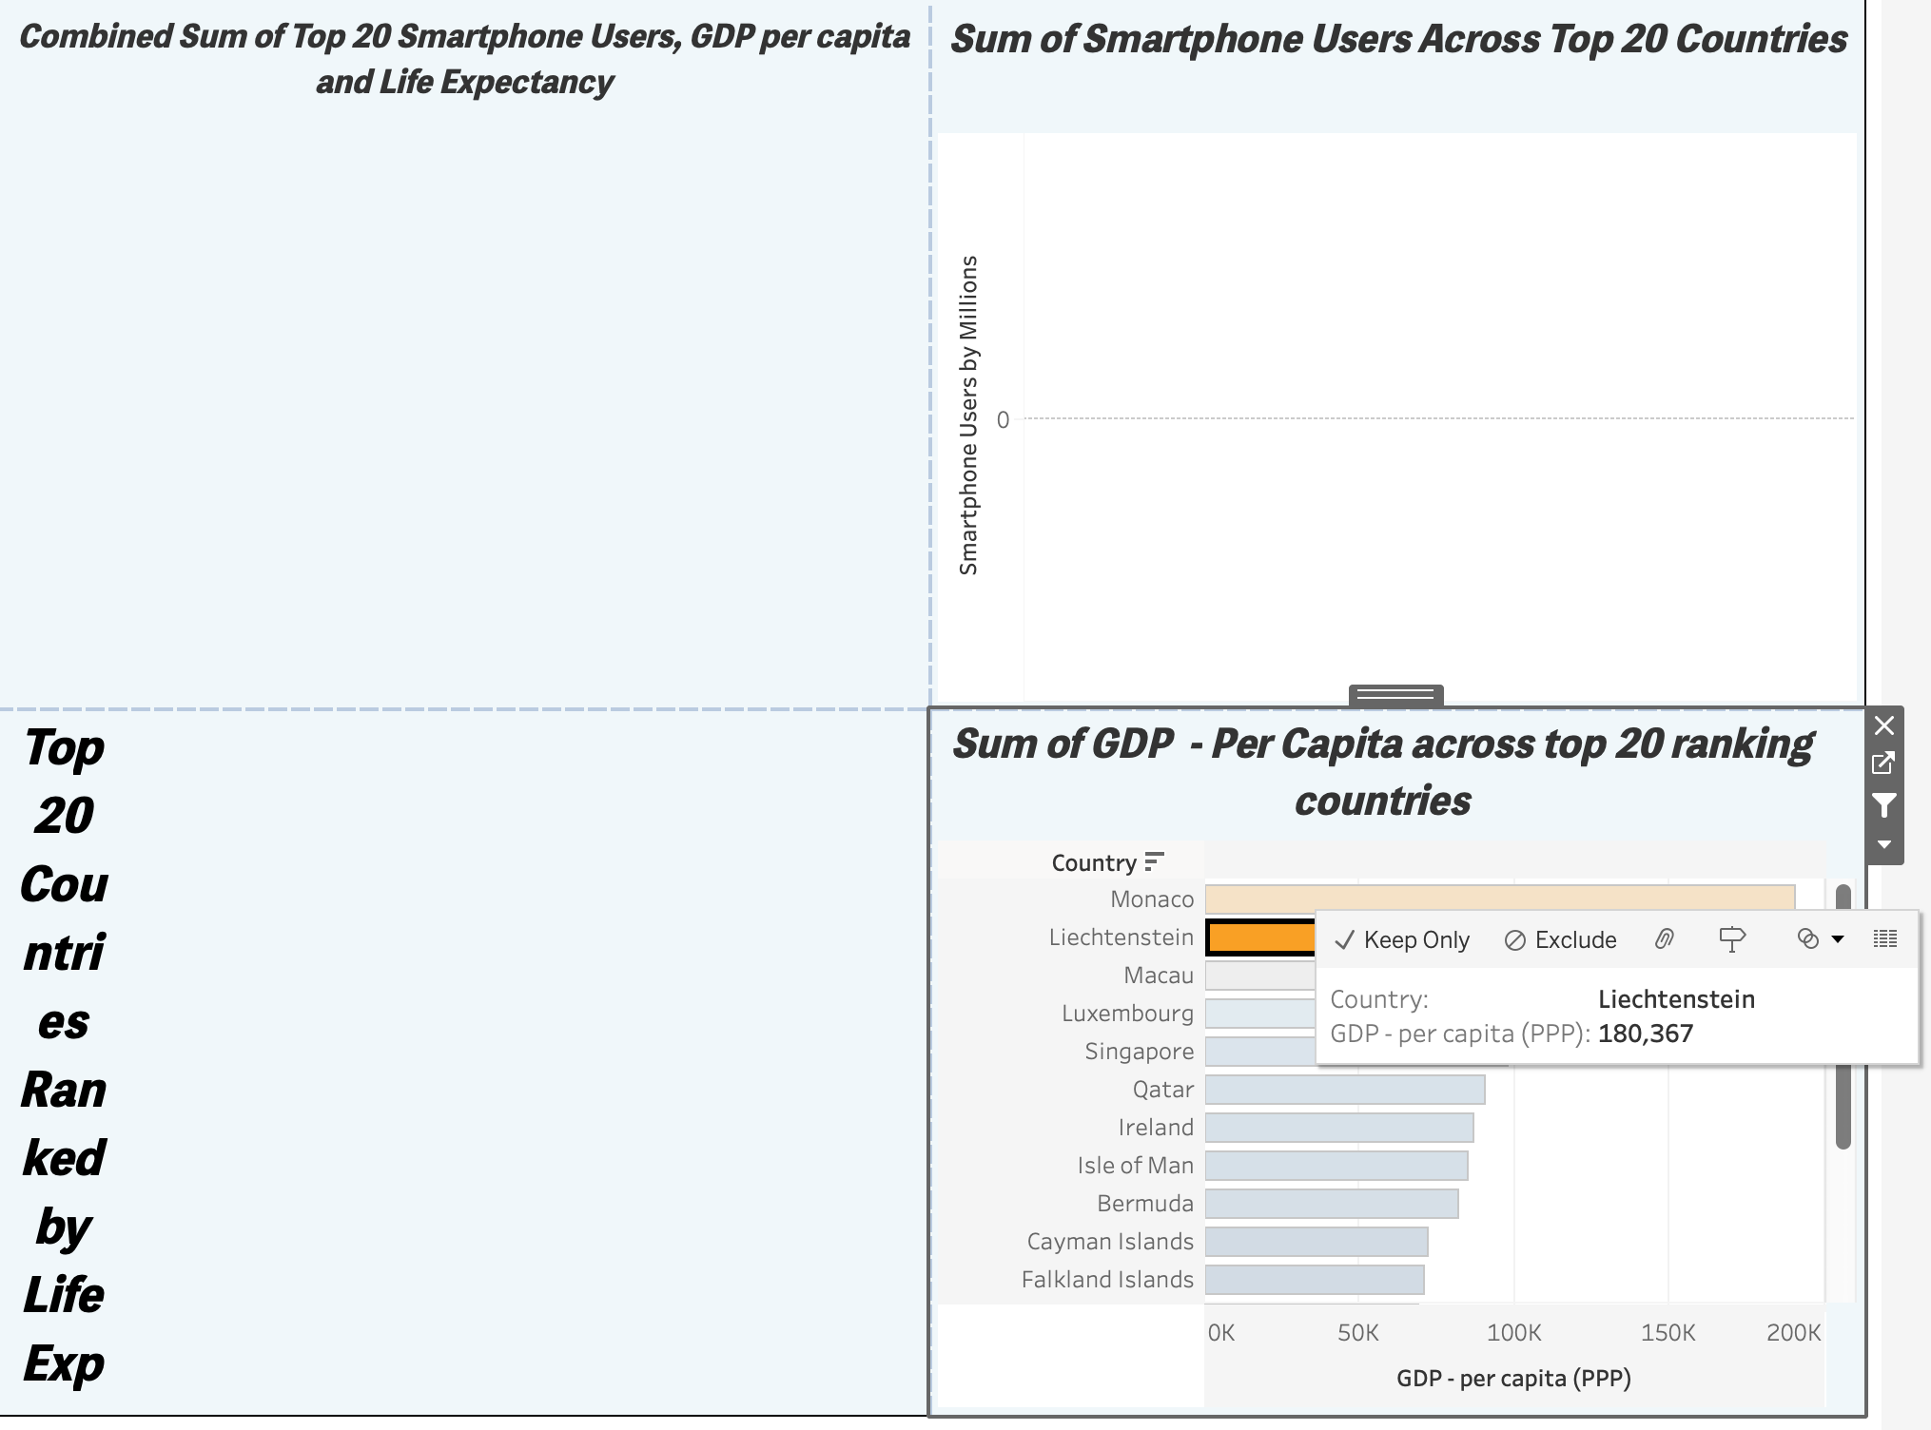

I did attempt to solve this issue by going back to my sheets and amending all my filters to the same rank, for example GDP – Per Capita across all four charts, however this did not resolve the filter issue and in fact reduced the accuracy of my charts originally created. I decided to upload my dashboard without filters. I came to this decision as I believe that it would be best practice not to provide a client with a faulty dashboard and instead just keep the dashboard un-interactive. If the client then asked for this function to be applied going forward, this could be provided in the future without the embarrassment of the client triggering a chart with the errors displayed above.

In conclusion I think I delivered consistent colour palette and user-friendly charts, with a variation across the 3 tables provided I feel they visually deliver information with little complication and with a measure of style.